Water Safety Ireland Course Registration Form

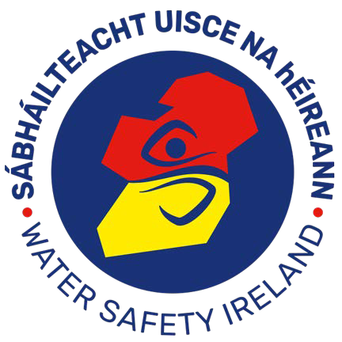
Swim Teacher Courses
Water Safety Ireland
The Long Walk Galway Web: www.watersafety.ie.ie Email: info@watersafety.ie

Tel: 091 564400

Signature:
Date Ratified:
Joanne Walsh, C E O
This form should be completed and forwarded to WSI National Office at least 14 days in advance of the start date of a Swim Teacher course. Course Providers will forward details to relevant WSACs. All tutors must be WSI members.
I agree to the management of my personal data in accordance with the General Data Protection Regulations (GDPR) 2018.

Assistant Swim Teacher Course  Full Swim Teacher Course
Organised by (tick appropriate box);
WSAC  WSI Approved Tutor  WSI Approved Organisation

Contact Details

Name:
Address:

Phone No: Fax No: E- Mail:

Course Details

Proposed starting date: Proposed concluding date:

Venue:
Number of Candidates:

Course Tutors: _ | Tel No
Course Examiners: | Tel No  Tel No
Timetable Details | Tel No | _
Theory Hours Practical Hours |  | Total Hours

Swim Teacher Manuals Required Assistant Swim Teacher Log Books Required
Full Swim Teacher Log Books Required

Office Use Only

