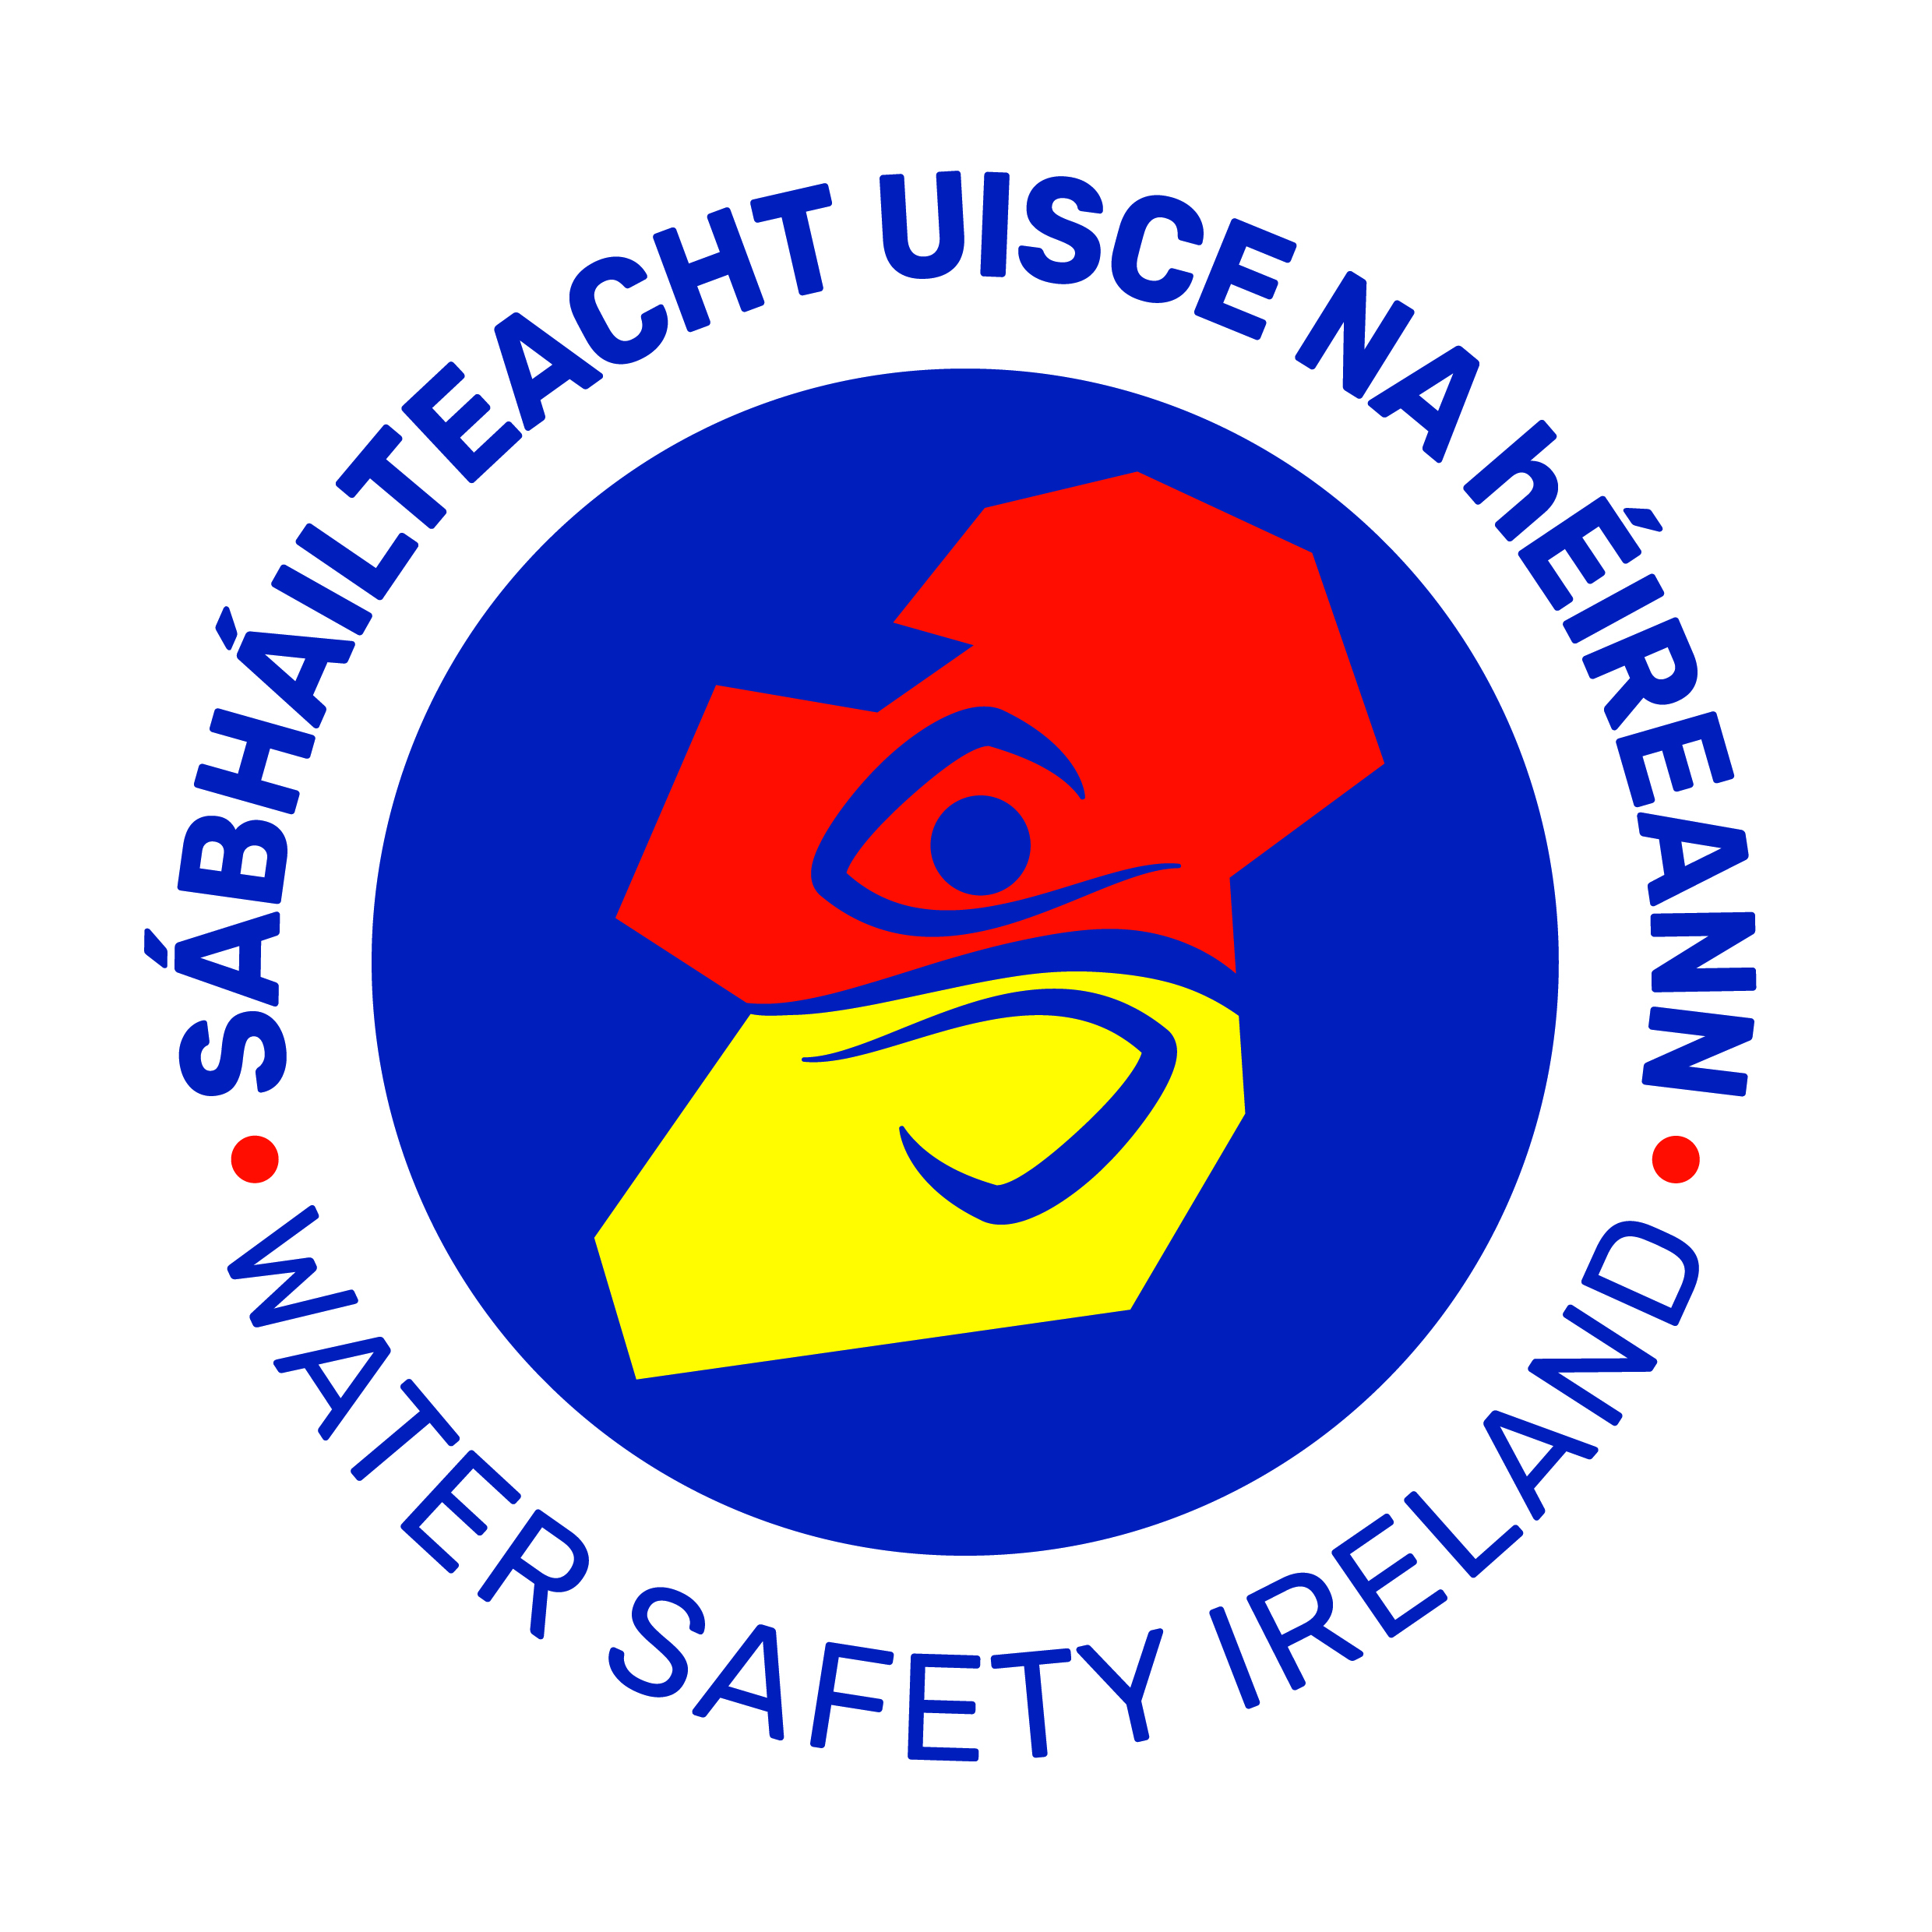
Code of Business Conduct
for Water Safety Ireland

Objectives
The basic objectives of the Code are to:
- Establish a set of ethical principles.
- Promote and maintain confidence and trust; and
- Prevent the development or acceptance of unethical practices.

General Principles:
- Management and employees should not be allowed to be involved in outside employment/business interests in conflict or in potential conflict with the business of the body.
- Avoidance of the giving or receiving of corporate gifts, hospitality, preferential treatment or benefits which might affect or appear to affect the ability of the donor or the recipient to make the independent judgment on business transactions.
- Commitment to compete vigorously and energetically but also ethically and honestly.
- Conduct of purchasing activities of goods/services in accordance with best business practice.
- Ensuring that the body’s accounts/reports accurately reflect their business performance and are not misleading or designed to be misleading.
- Avoidance or use of Water Safety Ireland’s resources or time for personal gain, for the benefit of persons/organisations unconnected with the body or its activities or for the benefit of competitors; and
- Commitment not to acquire information or business secrets by improper means.

Information
- Support by Council, Committee and Commission members, management and employees of Water Safety Ireland for the provision of access by the body to general information relating to Water Safety Ireland’s activities in a way that is open and that enhances it accountability to the general public.
- Respect the confidentiality of sensitive information held by Water Safety Ireland.
- This would constitute material such as:
  - Commercially sensitive information (including but not limited to future plans or details of major organisation or other changes such as restructuring).
  - Personal information; and
  - Information received in confidence by Water Safety Ireland.
- Observe appropriate prior consultation procedures with third parties where, exceptionally, it is proposed to release sensitive information in the public interest.
- Comply with relevant statutory provisions (e.g., General Data Protection Regulations; Freedom of Information Act; The Charities Act; Protected Disclosures Act 2014; Safety, Health and Welfare at Work Act; Disability Act; The Equality Act etc.)

Obligations
- Fulfil all regulatory and statutory obligations imposed on Water Safety Ireland.
- Compliance with detailed tendering and purchasing procedures as well as complying with prescribed levels of authority for sanctioning any relevant expenditure.
- Introduce controls to prevent fraud including adequate controls to ensure compliance with prescribed procedures in relation to claiming of expenses for business travel.
- Council Members should use their reasonable endeavours to attend all Council meetings; and
- Acceptance of positions following employment and/or engagement by Water Safety Ireland can give rise to the potential for conflicts of interest and to confidentiality concerns. The Council of Water Safety Ireland should, therefore, in a manner most effective to Water Safety Ireland, deal with the issue of post resignation/retirement employment, appointment and/or consultancy of its Council, Committee and Commission Members and employees by the private sector and should ensure that any procedures that it may have put in place in its regard are monitored and enforced.

Loyalty
- Acknowledge the responsibility to be loyal to Water Safety Ireland and fully committed in all its business activities while mindful that the organisation itself must always consider the interests of the members; and
- Acknowledge the duty of all to conform to the highest standards of business ethics.

Fairness
- Compliance with employment equality and equal status legislation.
- Commitment to fairness in all business dealings
- Value customers and treat all customers equally.

Work/External Environment
- Place highest priority on promoting and preserving the health and safety of employees.
- Ensure that community concerns are fully considered; and
- Minimise any detrimental impact of the operations on the environment.

I acknowledge that I have received and read the foregoing Code of Business Conduct for Water Safety Ireland.

_______________________________
Signature Employee
Water Safety Ireland

_______________________________
Name Printed

Date: __________________________

