Water Safety Ireland Child Safeguarding Statement
This is the national child safeguarding statement. Each individual location will post the risk assessement for that individual area and/or location.

- Name of service being provided: Water Safety Ireland (W. S. I)

- Nature of service:
Water Safety Ireland delivers swimming, lifesaving and water safety training and education to members of the public in swimming pools and at open water venues e.g., beaches, lakeshores & riverbanks. Water Safety Ireland is the Statutory Body responsible for developing Water Safety Awareness in Ireland. It also is the internationally recognised Governing Body for the sport of Lifesaving in Ireland.

- Principles to safeguard children from harm:
WSI recognises that the welfare and interests of children are paramount in all circumstances. It aims to ensure that all children have a positive and enjoyable experience while in its care and are protected from any harm or abuse whilst participating in all activities. It acknowledges that some children, including those less able can be particularly vulnerable to abuse or harm and accepts its responsibility to take reasonable and appropriate steps to ensure their welfare by working with the child's parents or carers.
As part of our safeguarding policy Water Safety Ireland will:
- promote and prioritise the safety and wellbeing of children and young people
- ensure everyone understands their roles and responsibilities in respect of safeguarding and is provided with appropriate learning to recognise, identify and respond to signs of abuse, neglect and other safeguarding concerns relating to children and young people
- ensure appropriate action is taken in the event of incidents/concerns of abuse and support provided to the individual/s who raise or disclose their concern
- ensure that confidential, detailed and accurate records of all safeguarding concerns are maintained and securely stored
- prevent the deployment of unsuitable individuals and maintain a safe recruitment and vetting policy
- Ensure that robust safeguarding arrangements and procedures are in operation.
Our guiding principles to safeguard children are contained in the “National Code of Ethics & Good Practice for Children” available at https://watersafety.ie/wp-content/uploads/2023/07/National-Code-of-Ethics-and-Good-Practice-for-Children-22-CEO_CO-Version-1.pdf
The following documents are also available for download:
Garda Vetting Forms at https://watersafety.ie/garda-vetting/
Social Media Policy at https://watersafety.ie/publications

- Risk Assessment:

We have carried out an assessment of any potential harm to a child while availing of our services including the area of online safety when accessing the internet. Below are a list of the areas of risk identified and the list of procedures for managing these risks. These can be found in the WSI Code of Ethics and Good Practice for Children and/or the WSI Members and Volunteers Policies documents.

 | Risk identified | Procedure in place to manage identified risk
1 | Lack of teaching qualification | - Instructor Training  - Recruitment policy
2 | Supervision issues | - Supervision policy  - Instructor Training
3 | Unauthorised photography & recording activities | - Photography and Use of Images policy
4 | Behavioural Issues | - Code of Conduct  - Complaints & Disciplinary policy
5 | Lack of gender balance amongst coaches | - Instructor Training  - Supervision policy
6 | No guidance for travelling and away trips | - Travel/Away trip policy  - Child Protection Training
7 | Lack of adherence with misc. procedures in Child Protection policy (i.e. mobile, photography, transport) | - Child Protection policy  - Complaints & disciplinary policy
8 | Lack of awareness of a Complaints & Disciplinary policy | - Complaints & Disciplinary procedure/policy  - Problem Solving Procedures
9 | Difficulty in raising an issue by child & or parent  Reason: Covered above | - Complaints & Disciplinary procedure/policy  - Reporting procedures
10 | Complaints not being dealt with seriously | - Complaints & Disciplinary procedure/policy
11 | Lack of knowledge of organisational and statutory reporting procedures | - Reporting procedures  - Instructor education  - Code of Conduct
12 | A child being bullied by a member/ volunteer or peer | - Child Protection policy  - Child Protection Training
13 | No DLP Appointed | - Reporting procedures
14 | Concerns of abuse or harm not reported | - Reporting procedures  - Child Protection Training – Level 1
15 | Not clear who young person or parent should talk to or report to | - Post the names of DLPs
16 | Unauthorised access to designated children’s play & practice areas and to changing rooms, showers, toilets etc. | - Supervision policy  - Instructor Training
17 | Unauthorised exit from children’s areas | - Supervision policy  - Instructor Training
18 | Photography, filming or recording in prohibited areas | - Photography policy and use of devices in private zones
20 | Children sharing facilities with adults e.g. dressing room, showers etc. | - Child Protection policy
21 | Child not collected at end of training | - Child Protection policy
23 | Recruitment of inappropriate people | - Recruitment policy
24 | Lack of clarity on roles | - Recruitment policy
25 | Unqualified or untrained people in role | - Recruitment policy
26 | Lack of awareness of ‘risk of harm’ with members and visitors | - Child Protection Policy  - Training policy
27 | No communication of Child Protection Statement or Code of Behaviour to  members or visitors | - Child Protection Statement – displayed  - Code of Conduct- distributed
28 | Inappropriate use of social media and communications by under 18’s | - Social Media Policy  - Code of Conduct
30 | Harm not being recognised | - Child Protection policy  - Child Protection Training
31 | Harm caused by  - child to child  - coach to child  - volunteer to child  - member to child  - visitor to child | - Child Protection policy  - Child Protection Training
33 | General behavioural issues | - Code of Conduct
34 | Cyber Bullying | - Social Media Policy

- Procedures

Our Child Safeguarding Statement has been developed in line with requirements under the Children First Act 2015, Children First: National Guidance for the Protection and Welfare of Children (2017), and Tusla’s Child Safeguarding: A Guide for Policy, Procedure and Practice. In addition to the procedures listed in our risk assessment, the following procedures support our intention to safeguard children while they are availing of our service:

- Procedure for the management of allegations of abuse or misconduct against workers/volunteers of a child availing of our service.
- Procedure for the safe recruitment and selection of workers and volunteers to work with children.
- Procedure for provision of and access to child safeguarding training and information, including the identification of the occurrence of harm.
- Procedure for the reporting of child protection or welfare concerns to Tusla.
- Procedure for maintaining a list of the persons (if any) in the relevant service who are mandated persons.
- Procedure for appointing a relevant person.

All procedures listed are available upon request.

- Implementation

We recognise that implementation is an on-going process. Our service is committed to the implementation of this Child Safeguarding Statement and the procedures that support our intention to keep children safe from harm while availing of our service.

This Child Safeguarding Statement will be reviewed on 1st Aug 2024 or as soon as practicable thereafter or if there has been a material change in any matter to which the statement refers to.

Signed:

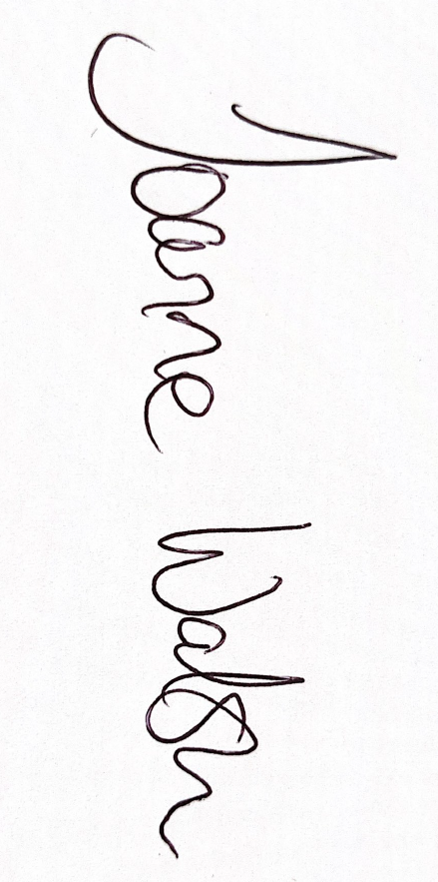

Joanne Walsh (Provider)
091-564400

For queries, please contact the above mentioned: Relevant Person under the Children First Act 2015.

