To be brought to the attention of all: Employees
/ Contractors / Visitors/Members
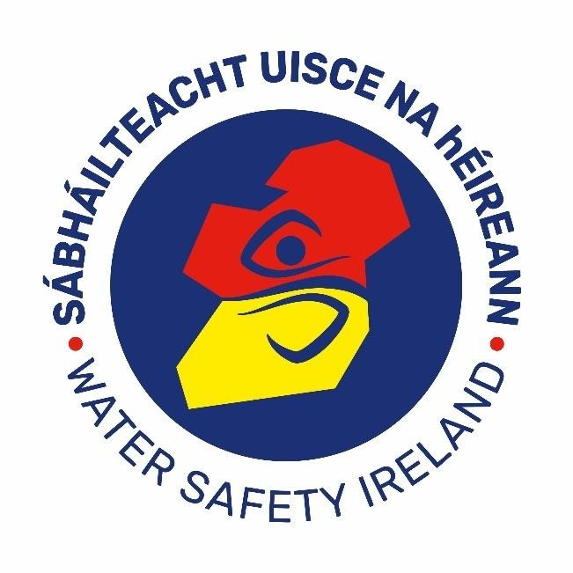

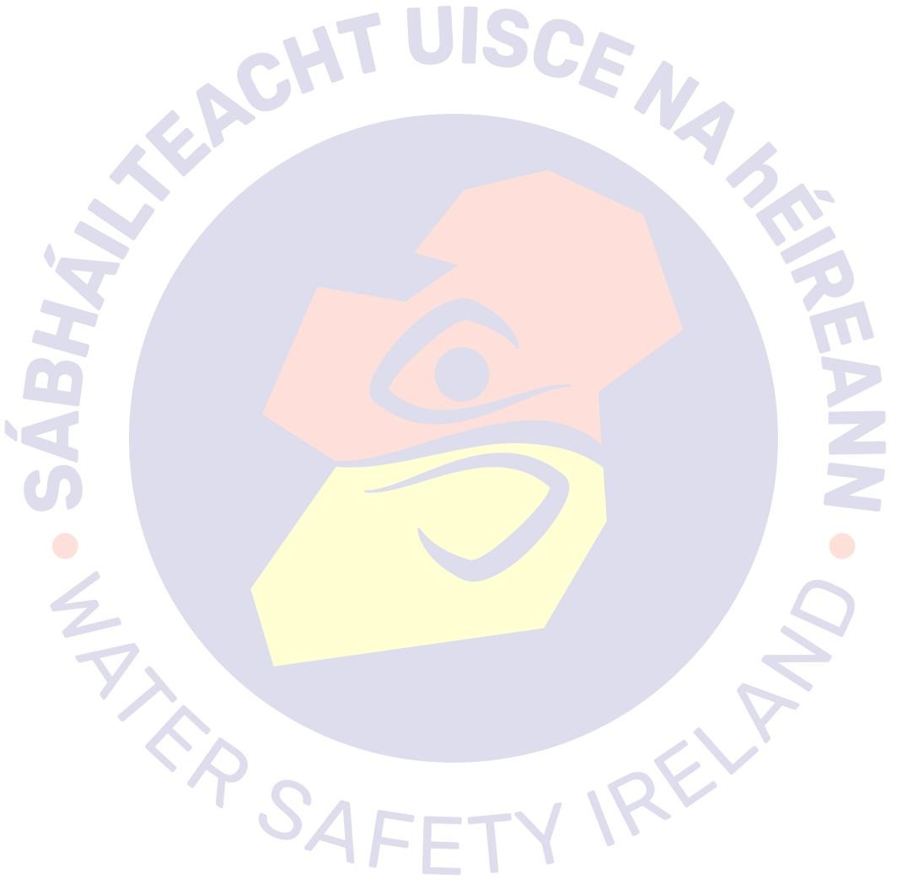
Water Safety Ireland The Long Walk Galway

Date | Version | Description | Prepared by | Approved
Sept 2003 | 1 | Safety Statement | IWS | CEO
Mar 2009 | 2 | Safety Review and Statement Update | Claren Safety | CEO
Nov 2018 | 3 | Safety Review and Statement Update | SafeAware | CEO
Oct 2020 | 4 | Safety Review and Covid update | SafeAware | CEO
Nov 2021 | 5 | Safety Review and Covid Update | J O’Neil | CEO
March 2022 | 6 | Updated contacts and First Responders | J O’Neil | Deputy CEO
August 2023 | 7 | Review | J. O’Neil | CEO

Table of Contents

Policy Statement………………………………………………… 4
Duties of the Employees 6
Duties of the Organisation Safety Coordinator 6
Responsibilities of the Area Committee 7
Responsibilities of Instructors / Members 7
Responsibilities of an Event Safety Adviser 8
Training 8
First Aid 8
Accident Reporting Procedures 9
Emergency Telephone Numbers 10
Accident Scene Management 11
Consultation on Health & Safety 11
Safety Committee 12
Relevant Legislation / Directives / Codes 12
Hazards & Risk Rating 13
Risk Rating Matrix 13
Personal Protective Equipment 14
Equipment 14
Housekeeping 14
HAZARDS – GENERAL 15
Bullying / Harassment / Challenging Behaviour 16
Drugs and Alcohol 17
First Aid and Accidents 18
House Keeping 19
Manual Handling 20
Major Incidents 21
Personal Protective Equipment 22
Remote Working………………………………………………..24
Sharps 24
Slips Trips and Falls 26
Fire 27
New / Young Workers 26
Pregnant Employees 27
Safety Signage 28
Shelving / Racking / Stacking 29
Stress – Normal working Operations 30
Violence to Staff 31
HAZARDS – CORONAVIRUS COVID-19 32
General: Infection Control in the workplace 33
Coronavirus – Covid-19 34
Coronavirus – Covid-19 continued 35
PREVENTION Washing Hands 36
PREVENTION Coughing / Sneezing Etiquette 37
PREVENTION Social Distancing 38
PREVENTION Cleaning 39
PREVENTION Visitors / Deliveries 40
HAZARDS – OFFICE 41
Slips Trips Falls 42
Temperature - Cold 43
Display Screen Equipment (DSE) 44
HAZARDS – Break Area 45
Hot Liquids / Surfaces 46
Microwave Oven 47
HAZARDS – COMPANY VEHICLES 48
Company Vehicles 49
Company Vehicles - Trailers 50
Refueling Machines / Vehicles 51
Recharging / Jump Starting - Batteries 52
HAZARDS – WATER SAFETY EQUIPMENT 53
CPR Mannequins 54
Rescue Boat – I.R.B. 55
Water Rescue Equipment – Ski’s and Boards 56
Quad Bikes 57
HAZARDS – WATER SAFETY COURSES 58
Beach + Pool Lifeguard Courses 59
Water Quality - Water Borne Diseases 60
Water Safety Weeks 61
HAZARDS – WATER SAFETY COMPETITIONS 62
Adverse Weather Conditions 63
Crowd Control 64
Swimmers - Open Water Activities 65
HAZARDS – WATER SAFETY MEMBERS 66
Bullying / Harassment / Challenging Behaviour 67
Drugs and Alcohol 68
Medical Conditions - At Risk Members 69
Special Needs Members 70
HAZARDS - MAINTENANCE 71
Chemicals 72
Electricity 73
Hand Tools 74
Ladders 75
Power Tools 76
Sub-Contractors 77
DECLARATIONS 78
Employees Declaration 79
Certificate of Compliance: Sub-Contractors 81

Policy Statement
Water Safety Ireland (WSI) recognises its duties under the prevailing Health & Safety legislation and is fully committed to enduring the health, safety and welfare of its employees. We will take all practical steps to meet, and, where required, exceed, our statutory duties at all times. We also acknowledge that we have responsibilities for the health and safety of others, such as contractors, visitors to our workplaces, members of the public and customers who may be affected by our undertakings.
In order to provide safe and healthy workplaces, systems of work, substances, equipment and working environment, we have developed and made available for all relevant persons this Policy Statement which shall be subject to regular reviews.
WSI Is dedicated to actively detecting and eliminating by controlling risks through risk assessments of new and existing work methods, areas, substances and equipment in order to eliminate or minimise risk. Such assessments shall be conducted through consultation so that as far as possible, employees will have an input. WSI shall provide ttime, resources and opportunity as necessary for this to occur.
Existing equipment and workplaces shall also be subject to regular inspection and maintenance. WSI is committed to preventing accidents and cases of work-related ill health. Appropriate training, education and information, instruction or supervision shall be provided as required. Procedures shall also be provided to assist with any emergencies.
WSI will be responsible and accountable to ensure that hazards are identified, reported, and controlled and that Employees have what is required for them to work safely.
All employees are required to cooperate with preventative actions by complying with work procedures, reporting issues they become aware of, using information and skills imparted to them through training and participating in any consultative forums.
WSI employees will be expected to comply with local site safety requirements and report hazards or incidents to their supervisor.
Contractors and visitors to our sites/work areas are expected to also cooperate with site Health, Safety and Environmental requirements to comply with all reasonable directions given to them. They shall also report any Health, Safety and Environmental issues of which they become aware.
The successful implementation of this policy requires all staff at all levels, to be fully committed to our Health, Safety and Environmental objectives.
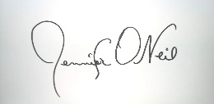

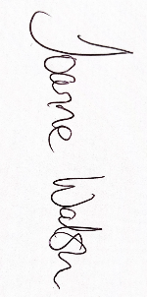
Joanne Walsh, CEO

Jennifer O’Neil, Safety Officer

Duties of the Employees
Employees are reminded of their responsibilities under the
2005 Safety, Health and Welfare at Work Act:
▲ Read and understand the company safety statement.
▲ Co-operate with management to enable him/her to comply with statutory provisions.
▲ Take reasonable care for their own safety, health and welfare and that of others.
▲ Make proper use of all equipment etc.
▲ Make proper use of personal protective equipment.
▲ Report immediately to management any defect in equipment, place of work or system of work, which might endanger the safety, health or welfare of which he/she becomes aware.
▲ Refrain from playing dangerous practical jokes or engage in horseplay.
▲ Report any injury to him/herself, which occurs at work even if the injury does not stop him/her from working.
▲ Suggest safer methods of work.
▲ Attend health and safety training provided by employer.

Duties of the Organisation Safety Coordinator
- Implement the company safety policies and procedures and monitor all aspects of health and safety within the company including adherence to current legislative requirements.
- Advise management on health and safety requirements, the resources required for their implementation and the ongoing reviews.
- Inspect / audit all locations and documentation to ensure that all legislative requirements are met and the necessary controls are implemented for all high-risk activities.
- Ensure that all testing and certification for machinery is carried out as required and that records are kept.
- Ensure that accidents record book(s) are kept, accidents are investigated / monitored, and the required remedial / statutory action taken.
- Ensure that dangerous occurrences are recorded / investigated, and the required remedial / statutory action taken.
- Identify the company’s on-going training needs and organise the necessary training.
- Accompany the HSA inspector on visits and consult with them as required.

Responsibilities of the Area Committee

- Implement the organisation safety policies and procedures and monitor all aspects of health and safety within the local area including adherence to current legislative requirements.
- Select suitable persons for the control of WSI activities and seek approval from HQ WSI.
- Advise WSI on health and safety requirements relevant to their area and the required resources.
- Inspect / audit all locations used for WSI activities and documentation to ensure that all legislative requirements are met and the necessary controls are implemented for all high-risk activities.
- Ensure that all testing and certification for appropriate equipment is carried out as required and that records are kept.
- Ensure that accidents / dangerous occurrences are reported to WSI when required.

Responsibilities of Instructors / Members
Instructors / Members are reminded of their responsibilities under the
Safety, Health and Welfare Legislation

- Read and understand the relevant sections of the WSI safety statement.
- Co-operate with the WSI officers / local area water safety committee to enable the WSI to comply with applicable statutory provisions.
- Take reasonable care for their own safety, health and welfare and that of others under their control.
- Make proper use of all equipment etc.
- Make proper use of personal protective equipment.
- Report immediately to WSI any defect in accommodation, locations, equipment, support, and information which might endanger the safety, health or welfare of which he/she becomes aware.
- Refrain from playing / permitting dangerous practical jokes or engage in horseplay.
- Report any injury to him/herself and or to members under their control, which occurs at work even if the injury does not stop him/her from working.
- Where applicable, advise WSI on any additional safety recommendations / suggestions they may have.
- Attend health and safety training provided by WSI.

Responsibilities of an Event Safety Adviser

- The adviser will be fully conversant with the required Code and Guidance notes of WSI.
- Assess the risks to the event participants both in and off the water.
- Implement the WSI safety policies and procedures and monitor all aspects of health and safety within the event including adherence to current legislative requirements.
- Advise WSI / local area committee on health and safety requirements, the resources required for safe running of the event.
- Inspect / audit all locations and documentation to ensure that all legislative requirements are met and the necessary controls are implemented for all high-risk activities.
- Ensure that all testing and certification for equipment is carried out as required and that records are kept.
- Ensure that all accidents / dangerous occurrences are reported / recorded / investigated and the required remedial / statutory action taken.
- Oversee the safety arrangements for event etc.

Training
Employee training will be conducted in all areas relevant to health and safety. :
▲ Safety Awareness
▲ Occupational First Aid (FETAC)
▲ Manual Handling

The persons responsible for this is - CEO

First Aid
First Aid Equipment, to include a first aid kit, will be available in the house. The person responsible for the provision and periodic checking of first aid kits is: CEO

Accident Reporting Procedures
Reporting of Accidents and Dangerous Occurrences) Regulations (S.I. No. 370 of 2016)
Fatal accidents in the workplace should be reported immediately to the Health & Safety Authority or the Gardaí so that the necessary action, including any investigation by the Authority, can take place. Subsequently, the formal accident report form should be submitted to the Authority within five working days of the death. Non-fatal accidents or dangerous occurrences should be formally reported within 10 working days of the event.
The Safety Coordinator is responsible for Reporting Accidents.
In relation to your employees: You must report the death of an employee if this is as a result of an accident at work.
The accident may have taken place either at your place of work or at another employer’s place of work or in a location other than the normal place of work.
The following are examples of reportable fatalities:

- An employee is fatally injured as a result of being hit by a delivery truck in your premises.
- An employee is fatally injured while driving for work on a public road.
- An employee is fatally injured while carrying out contract work for another employer at their site.
You must report the injury of any employee as a result of an accident while at work where the injury results in your employee being unable to carry out their normal work for more than three consecutive days, excluding the day of the accident. In calculating the days, you should include weekends and other non-working days.
Examples of reportable accidents:

- An employee, which includes a trainee, who normally has Saturday and Sunday off work, is injured on Wednesday and returns to work the following Monday.
- A driver or a passenger is involved in a road traffic accident while driving or riding in the vehicle in the course of work and he is out of work for more than three days.
- An employee, while lifting boxes on Monday, hurts her back. She returns to work on Thursday, but she can only do light duties for the next week. Even though she was not absent for more than three days, she could not perform her normal work for more than three days.
You must report any case where an employee dies as a result of an accident at work within one year of that accident, even if you had already reported the accident.

In relation to non-employees (non-workers, members of the public, employees of another enterprise) at your place(s) of work:
- You must report the death of a person who is not your employee and who is not at work, but who dies from an accident caused by a work activity at the place of work.
  - For example, if you are responsible for moving patients and a member of the public is injured by a reversing vehicle in the course of the work, and subsequently dies as a result of their injuries, then you must report that accident.
- You must report the injury of a person who is not your employee and who is not at work but who is injured from a work activity if the injured person has had to be taken from the location of the accident to receive treatment in respect of that injury in a hospital or medical facility. For the purposes of these Regulations, a medical facility can include a primary care facility, a medical care clinic, or a medical facility at a work site that is staffed by a registered medical practitioner.
Example of accidents that must be reported:
- There is a road collision involving your employee driving for work and a member of the public driving a car. The member of the public is injured and required to be taken to and treated in hospital or medical facility.
Dangerous occurrences listed in Appendix 1 of these Regulations are required to be reported.
The Person responsible for Reporting Accidents is CEO

Emergency Telephone Numbers
Local Doctor (Galway Bay Medical Centre) | 091 530054
Local Hospital UCHG | 091 524222
Fire Brigade | Tel: 999 / 112
Ambulance Service | Tel: 999 / 112
Gardaí | Tel: 999 / 112
Local HSA | Tel: Lo Call: 1890 289 389

Occupational First Aiders |  | Fire Wardens
Jennifer O’Neil | Emer Gardiner
Roger Sweeney | Padraig Judge | Roger Sweeney
Jocelyn Cunningham | Ciara Gleeson | Jennifer O’Neil
Alison Elstone

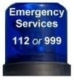
Accident Scene Management
- A member of management / senior person present will take charge of the proceedings.
- The immediate accident scene will be made safe.
- All helpers will ensure their own personal safety before assessing the casualty(ies).
- The necessary first aid will be administered.
- If necessary, the emergency the "blue light" services - Garda Síochána, ambulance, fire and Irish Coast Guard) will be notified with the following information:
  - Type of accident - details on the incident:
    - The number of persons involved.
    - The description of any visible injuries.
    - Knowledge of any pre-existing medical conditions.
  - Location: the exact address of the incident or emergency and/or any noticeable landmarks nearby, and directions to the scene of the emergency
  - Telephone number you are calling from•
  - Always remember, it is important to wait for the call-takers instructions, try and stay calm and don’t hang up until they tell you to.
- The casualty will only be moved if there is an immediate danger / threat to his/her safety.
- The casualty will be treated for shock (he/she will be placed in a safe position for his/her particular condition, kept warm, comforted and reassured).
- Other persons present will be asked provide the required assistance.
- WSI will be notified.
- The accident scene will be preserved in any case that warrants investigation by the Health & Safety Authority.
- All details of the accident / witnesses will be collected by person in charge.
- The entry in accident report book will be completed. The accident scene will be sketched / photographed. The accident report may be submitted to insurer as necessary.

Consultation on Health & Safety
WSI is committed to meeting his obligations under the Safety, Health and Welfare at Work Act 2005 on consultation and will meet with Employees monthly, to discuss health and safety aspects at work.

Safety Committee
A safety committee will be formed and will meet regularly to discuss any ongoing safety concerns. The safety committee will comprise of management, and employees. Minutes of meeting will be kept and actioned items passed on to relevant departments. Safety Committee will require details of all incidents since its previous meeting, if any, and put in place controls to prevent the same type of incident occurring again.

Relevant Legislation / Directives / Codes
▲ Occupiers Liability Act 1955
▲ Safety, Health and Welfare at Work Act, 2005
▲ Safety, Health and Welfare at Work (General Applications) Regulations 1993
▲ Safety, Health and Welfare at Work (General Applications) Regulations 2007, Part 4 (Work at Height)
▲ Safety, Health and Welfare at Work (Miscellaneous Welfare Provisions) Regulations, 1995
▲ Safety, Health and Welfare (Noise) Regulations 2006
▲ Safety, Health and Welfare at Work (Confined Spaces) Regulations, 2001 (S.I No. 218 of 2002)
▲ Chemical Agents Regulations, 2001
▲ Chemicals Act 2008 (No.13 of 2008 and Chemicals (Amendment) Act 2010 (No 32 of 2010)
▲ Safety, Health and Welfare at Work (General Applications) (Amendment)
▲ Safety Health and Welfare at Work (Biological Agents) Regulations 2013
▲ Safety, Health and Welfare at Work (General Application) Amendment) Regulations 2016 (S.I. No. 36 of 2016)
▲ Reporting of Accidents and Dangerous Occurrences) Regulations 2016 (S.I. No.
370 of 2016)

WSI SOP’s
Bullying & work-related stress | Office Work General
Use of Tea Station facilities | Prevention of Fire/Emergency
Cleaning of Offices | Security of Office Facilities & Equipment
Dealing with the public/cash transit | Use of ladders (fixed, mobile & step ladders)
Document storage and filing cabinets | Use of Office Equipment
Driving operations of WSI vehicles | Use of PPE (Personal Protective Equipment)
Driving operations of own vehicle for work use | Use of Steps and stairs
Electricity & electrical appliances | Visual Display Units
Manual Handling | Working outside in all weather
New and Expectant Mothers | Young People at Work
Provision of Office Welfare Arrangements | Use of Mobile Phones

Note: - All employees are duty holders in law, supervisors and managers have additional duties. Any employee who jeopardises their safety or that of others - or who fails to observe safety rules - is subject to corrective action up to and including dismissal.

General Principles of Prevention
1. Evaluation of unavoidable risks | 6 Replacement of dangerous articles, substances or systems of work by non-  dangerous or less dangerous one
2. Combating risks at source | 7 Development of prevention policy
4 Adaptation of work to the individual | 8 Collective protective measures
5 Adaptation of work to technical progress | 9. Appropriate training and instruction to Employees

Hazards & Risk Rating
Hazard: Anything with the potential to cause harm.
Risk: The likelihood, great or small, that someone will be harmed by the hazard, together with the severity of the harm suffered.
Harm: Is often referred to as ‘physical injury’, ‘psychological injury’ or damage.

Risk Assessment Is a careful examination of what could cause harm to people so that you can weigh up whether you have taken enough precautions or should do more to prevent them.
Risk Rating Matrix

 | Certain (5) | Very Likely (4) | Likely (3) | May happen (2) | Unlikely (1)
Fatal Injury (5) | 25 | 20 | 15 | 10 | 5
Major injury, hospitalisation (4) | 20 | 16 | 12 | 8 | 4
Significant injury / A&E (3) | 15 | 12 | 9 | 6 | 3
Minor injury (first aid to be found (2) | 10 | 8 | 6 | 4 | 2
Minor injury (first aid immediately available (1) | 5 | 4 | 3 | 2 | 1

Score | Priority | Action
1 – 4 | LOW | This represents a low risk, although control measures must be maintained (GREEN)
5-10 | MEDIUM | Action required soon to control. Interim measures may be required in the short term. (YELLOW)
12 – 25 | HIGH | Action required urgently to control the risks. Activity NOT advised. (RED)

Personal Protective Equipment
▲ Only suitable and appropriate PPE which complies with European Community Directives, will be used / worn.
▲ The PPE will only be used for the purpose specified and will be maintained in good working order and in a satisfactory hygienic condition.
▲ WSI will provide necessary PPE for all employees.
▲ Sub-Contractors are responsible for supplying all their staff with appropriate PPE for the tasks undertaken.

Equipment

Footwear  Non-slip Boots / Shoes |  | Hands  Good grip gloves
Life Jacket / Personal Floatation Device | 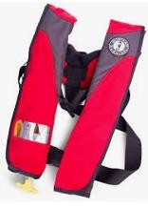 | High Vis Clothing | 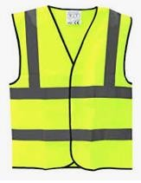
Rainwear

Housekeeping

▲ All employees will operate a "clean as you go" policy.
▲ All rubbish will be removed to a skip at the end of each shift.
▲ Periodic checks will be carried out by the person in charge to ensure that no obvious danger exists that might endanger the staff.
▲ All areas will be kept clear of obstructions.
▲ All employees will adopt good housekeeping practices.
▲ Employees will report to management any unusual conditions they discover.
▲ All slip/trip /fall hazards to be removed immediately.

“CLEAN WORKPLACE, SAFE WORKPLACE”

HAZARDS – GENERAL

Bullying / Harassment / Challenging Behaviour

Hazards: | Bullying, Harassment, Challenging Behaviour
Type of Activity: | Normal Work Activities
Risk To: | Employees / Members / Public |  | Risk Rating | LOW
Consequences | Emotional Illness / Fear / Anxiety / Depression
Findings | - Water Safety Ireland will not tolerate bullying under any circumstances
Current and additional control measures
- Staff / members are required to explicitly follow:
  - WSI Guidelines on Child Protection are followed by all instructors.
  - WSI National Code of Ethics and Good Practice guidelines.
  - Updated Handbook which includes Dignity at Work Policies
- All incidents of such behaviour will be reported and investigated immediately and the necessary corrective action taken.
- Regular briefings on the signs/effects of bullying will take place with employees.
- The cooperation of management and employees is required.
Person Responsible: |  | All personnel
Training Requirements |  | Health & Safety Induction on safety policies.

Drugs and Alcohol

Hazards: | Loss of control
Type of Activity: | Normal Work Activities
Risk To: | Employees / Members / Public |  | Risk Rating | LOW
Consequences | Injury / Loss of limb / Loss of life
Findings | - Employees monitored by Management.  - Members are monitored by local area committee.  - WSI’s Code of Ethics guidelines outline organisations policy on Drugs and alcohol.
Current and additional control measures
- Employees suspected of alcohol consumption must be reported to the safety co- ordinator.
- The use and possession of illegal substances is strictly forbidden and will result in disciplinary procedures.
- Company will develop a Drugs and Alcohol policy and implement same.
- No employee will be under the influence of intoxicants at any time while working.
- The consumption of alcohol while working is forbidden as is arriving at work after partaking of alcohol.
- Employees will / may be required to undergo random test for intoxicants with a nominated doctor as per current Legislation.
Person Responsible: |  | Employer / All employees
Training Requirements |  | Health & Safety Induction on safety policies.

First Aid and Accidents

Hazards: | Inadequate/inexperienced treatment / Out of Date Supplies
Type of Activity: | General Work Activities
Risk To: | Employees / Members / Public |  | Risk Rating | MEDIUM
Consequences | Injury / Spinal Injury / Death
Findings | Fully qualified first aider present at all times. Accident book is available and is maintained.  Automated Defibrillator and qualified staff on-site.
Current and additional control measures
- At least one-member staff on duty should have Occupational First Aid.

- Detailed records of all first aid given will be maintained.

- First Aid kits will be checked and restocked on a regular basis.

- Staff will receive Occupational First Aid refresher training two years.
Person Responsible: |  | Employer
Training Requirements |  | Health & Safety Induction on safety policies.
If all measures are followed properly, this activity will reduce the risk rating from Medium to Low risk.

House Keeping

Hazards: | Slippery surfaces, Poor housekeeping, Poor lighting in Office
Type of Activity: | Access and Egress / General movement
Risk To: | Employees / Members / Public |  | Risk Rating | MEDIUM
Consequences | Back / Hand injury / Herniated Disc / Pulled Muscle
Findings | Housekeeping requires regular attention in Offices and Storage areas. Storage areas present access/egress, slip, trip and fall hazards.  Alternative storage required for promotional materials and archive documentation
Current and additional control measures
- Areas will be kept free of debris, trash, spills at exits and particularly passageways.
- Protruding objects (that can block walkways) will be removed.
- Employees will report to management any unusual conditions they discover.
- All Employees will operate a "clean as you go" policy.
- Employees will report to supervisor if poor lighting conditions exist.
- Periodic checks will be carried out to ensure that no obvious danger exists that might endanger the employees / members.
- Organisers of WSI events will ensure that members bags/sports gear is stored / organised so as not to pose a hazard.
- All seating / tables etc. will be organised to facilitate easy access and egress.
Person Responsible: |  | Employer
Training Requirements |  | Health & Safety Induction on safety policies.
If all measures are followed properly, this activity will reduce the risk rating from Medium to Low risk.

Manual Handling

Hazards: | Overreaching / Lifting Heavy Items - Slips / Trips / Falls, Poor lighting, poor lighting
Type of Activity: | Carrying / Moving, Pulling / Pushing
Risk To: | Employees / Members / Public |  | Risk Rating | MEDIUM
Consequences | Back injury / Hand injury / Hernia / Muscle tear / Cramp / Crush injuries
Findings | Staff will not be asked or required to lift anything outside their capabilities.  Storage areas present access/egress, slip, trip and fall hazards
Current and additional control measures
- All staff at risk will be trained in manual handling techniques.
- Only suitably trained employees will carry out two person lifts.
- Areas are kept clear of obstructions & substances that will contribute to slips/trips/falls.
- No person who has a history of back trouble will undertake any manual handling task.
- Work will be arranged to avoid over-reaching or twisting when handling loads.

- Employees will not carry anything that obscures their vision or puts their back at risk.

- Mechanical lifting devices to be used where possible.
- Employees will not carry anything that obscures their vision or puts their back at risk.
- Manual handling tasks will be kept to a minimum.
- Tasks that require reaching over heart height and/or twisting of the lumbar region must be avoided.
Staff are encouraged to use trolleys to assist in lifting and carrying wherever possible. All trolleys / combi’s units will:
- Be maintained as per the manufacturers / supplier’s instruction.
- Not pose a risk to customers / staff.
- Be stored so as not to hinder access to emergency equipment.
- Not be overloaded so as to obscure vision or pose a risk of a back injury.
- Loaded combi’s will be pushed rather than pulled.
- All trolleys / combi’s
  - Must NOT be parked on fire escape routes.
  - When used for stacking shelves will be removed from the shop floor during breaks / interruptions of the task.
  - When used for stacking shelves will be sited so as not to pose a risk to other shop users.
  - Must be secured at night to prevent unauthorised use.
  - All combi’s will be moved from shop floor when not in use or during breaks periods.
- All staff will be instructed on the dangers of blocking fire exits. All staff will remove
trolleys or combi’s that are blocking fire exits.
Person Responsible: |  | Employer
Training Requirements |  | Staff at risk will be trained in Manual Handling.
If all measures are followed properly, this activity will reduce the risk rating from Medium to Low risk.

Major Incidents

Hazards: | Inclement weather, fast flowing waters, flooding, Fire, Storms, Loss of vital services
Type of Activity: | Incidents
Risk To: | Employees / Members / Public |  | Risk Rating | MEDIUM
Consequences | Injuries, death
Findings
Current and additional control measures
▲ Major incidents, all-hazard plan written/reviewed in accordance with required standards and procedures.
▲ A nominated senior person with overall responsibility for all aspects of response to a major incident and up-to-date contact details for nominated person (including out of hours) are accessible for staff working in the hospital.
Person Responsible: |  | Employer
Training Requirements |  | Health & Safety Induction on safety policies.
If all measures are followed properly, this activity will reduce the risk rating from Medium to Low risk.

Personal Protective Equipment

Hazards: | Unsuitable PPE / Damaged PPE / Unhygienic PPE
Type of Activity: | Work Activities
Risk To: | Employees / Members / Public |  | Risk Rating | MEDIUM
Consequences | Ill-health / Respiratory Illnesses / Lung Damage / Head Injuries / Cuts Scrapes
Findings | PPE available where required.
Current and additional control measures
- Where required, employees will wear the necessary PPE.
- Only suitable and appropriate PPE which complies with European Community Directives will be used / worn.
  - Safety Eye Protection (Glasses, Goggles and Visors) EN 166
  - Safety Footwear Protection (Boots and Shoes) EN345 S3
  - Safety Hand Protection (Gloves and Gauntlets) EN 374
  - Ear protection EN 352-2
  - High Vis Clothing EN 471
- The PPE will only be used for the purpose specified and will be maintained in good working order and in a satisfactory hygienic condition.
- Management will carry out regular checks on PPE to ensure it is being worn, maintained in appropriate fashion and cleaned on a regular basis.
- Contractors are required to wear PPE appropriate to the work they are carrying out.
Person Responsible: |  | Employer
Training Requirements |  | Health & Safety Induction on safety policies.
If all measures are followed properly, this activity will reduce the risk rating from Medium to Low risk.

Remote Working

Hazards: | Poor lighting, Poor Ventilation, Fire Hazards, other health and safety risks, Isolation, Lack of Motivation
Type of Activity: | Working Remotely vs in an office setting with colleagues in close physical proximity
Risk To: | Employees |  | Risk Rating | MEDIUM
Consequences | Possible H&S Risks, decreased performance
Findings | Workspace Assessments Regularly Conducted
Current and additional control measures
- WSI recognises their responsibility under the Safety, Health and Welfare at Work Act 2005: As an employer, WSI has the responsibility to ensure employees have a safe workspace. A Workspace Assessment will be carried out in respect of the following:
  - The available technology to ensure all tasks can be completed remotely.
  - How work is organised in the place of work.
  - Working conditions, including adequate lighting, adequate ventilation, proper fire safety evacuation plan and alarms, reduced risk of slips trips and falls.
  - The influence of factors related to the working environment, such as the location of the workspace, and also the level of engagement workers have with colleagues and management.
- Management will provide clear KPIs and targets to ensure clarity and sense of achievement and motivation are maintained.
- Management will facilitate the purchase of any additional tools or equipment as necessary to ensure workers can complete all tasks remotely.
- Management will encourage and facilitate regular check ins with each employee, both individually and as teams.
Person Responsible: |  | Employer
Training Requirements |  | Briefing on the relevant Water Safety Ireland policies
If all measures are followed properly, this activity will reduce the risk rating from Medium to Low risk.

Sharps
Hazards: | Broken Glass / Nails / needles
Type of Activity: | Cleaning / Servicing
Risk To: | Employees / Members / Public |  | Risk Rating | MEDIUM
Consequences | Lacerations / Blood Loss / Infections
Findings | First Aid Kits kept on site
Current and additional control measures
- A Sharps Risk Assessment will be carried out in respect of the following:
  - The available technology that eliminates or reduces the risk of exposure.
  - How work is organised in the place of work.
  - Working conditions.
  - The influence of factors related to the working environment.
  - The level of qualifications of relevant workers.
- Staff will wear appropriate puncture protective footwear and use gloves when gathering the glass / sharps / nails.
- All scrap timbers with protruding nails will be rendered safe.
- All glass / needles / sharps will be collected while wearing puncture proof gloves and disposed of appropriately.
Person Responsible: |  | Employer
Training Requirements |  | Briefing on the relevant Water Safety Ireland policies
If all measures are followed properly, this activity will reduce the risk rating from Medium to Low risk.
Hazards: | Broken Glass / Nails / needles
Type of Activity: | Cleaning / Servicing
Risk To: | Employees / Members / Public |  | Risk Rating | MEDIUM
Consequences | Lacerations / Blood Loss / Infections
Findings | First Aid Kits kept on site
Current and additional control measures
- A Sharps Risk Assessment will be carried out in respect of the following:
  - The available technology that eliminates or reduces the risk of exposure.
  - How work is organised in the place of work.
  - Working conditions.
  - The influence of factors related to the working environment.
  - The level of qualifications of relevant workers.
- Staff will wear appropriate puncture protective footwear and use gloves when gathering the glass / sharps / nails.
- All scrap timbers with protruding nails will be rendered safe.
- All glass / needles / sharps will be collected while wearing puncture proof gloves and disposed of appropriately.
Person Responsible: |  | Employer
Training Requirements |  | Briefing on the relevant Water Safety Ireland policies
If all measures are followed properly, this activity will reduce the risk rating from Medium to Low risk.

Slips Trips and Falls

Hazards: | Slippery surfaces / Poor housekeeping / Poor lighting / Uneven Ground
Type of Activity: | Access and Egress / General movement
Risk To: | Employees / Members / Public |  | Risk Rating | MEDIUM
Consequences | Injuries / Cuts / Scrapes / Bruising /Broken Limbs
Findings | Housekeeping requires regular attention in Offices and Storage areas. Storage areas present access/egress, slip, trip and fall hazards  Alternative storage required for promotional materials and archive documentation
Current and additional control measures
- All areas will be kept free of debris, trash, spills at exits / passageways.
- Unused work equipment will be stored away.
- Housekeeping / cleaning programme in place to manage the yard and site work floor, regular checks carried out.
- Periodic checks are carried out to ensure that no obvious danger exists that might endanger the Employees / Members / Public.
- Protruding objects (that can block free passage/walkways) will be removed.
- Employees will report to management any unusual conditions they discover.
- All Employees will operate a "clean as you go" policy.
- Employees will report to supervisor poor lighting on site and wait for additional lighting to be secured before commencing with work activity.
- The yard/sheds etc. shall be kept clear of any rubbish / debris.
- Areas / walkways will be kept clear of obstructions.
Person Responsible: |  | Employer
Training Requirements |  | Regular Housekeeping checking and Safety Awareness
If all measures are followed properly, this activity will reduce the risk rating from Medium to Low risk.

Fire

Hazards: | Fire / Explosion / Combustible liquids / Inadequate numbers of fire extinguishers / Blocked Fire Exits
Type of Activity: | Normal house activities
Risk To: | Employees / Members / Public |  | Risk Rating | LOW
Consequences | Burns / Scalds / Death / Scaring / Smoke inhalation / Lung Damage
Findings | All fire protection equipment currently in date.
Current and additional control measures
- All areas will be maintained free from fire hazards, as far as is reasonably practical.
- Areas (inside and out) will be kept clear of any accumulation of rubbish & combustible materials.
- Solvents / cleaners will be stored correctly and in their correct containers.
- No sources of ignition will be within reach of these materials.
- An appropriate & suitable number of fire extinguishers will be available.
- Staff will be trained in the recognition of the causes of fire, the correct type of fire extinguisher to be used and how to raise the alarm.
- All occupants will be familiar with at least two escape routes from their work area, also with the fire extinguishers in their area.
- All passageways/escape routes must be kept clear.
- All firefighting equipment will be maintained as per current legislation.
- There must be unrestricted access to firefighting equipment at all times.
- Smoking within the building is prohibited.
- Maintain at least 30" of clearance around all sources of ignition such as heaters, boilers, and electrical panels.
Person Responsible: |  | Employer
Training Requirements |  | Health & Safety Induction on safety policies.

New / Young Workers

Hazards: | Young / Inexperienced Workers / Non-nationals / Lack of Knowledge / Lack of understanding of Safety Signs / Rules / Controls
Type of Activity: | Normal activities
Risk To: | Employees / Members / Public |  | Risk Rating | LOW
Consequences | Injury / Fire
Findings | No persons under sixteen years will be employed
Current and additional control measures
- All new / young employees / non-nationals undergo induction training prior to working.
- Records will be kept of induction training.
- This induction training will include the contents/implications of the safety statement, fire safety, general safety, the wearing and use of personal protective equipment, care and maintenance of PPE.
- Induction will be carried out prior to the commencement of the work.
- Only when management is satisfied that the person is competent, will they be permitted to work.
- All young / inexperienced workers will be under the direct supervision of a competent person for the duration of their training.
- All safety documentation / training will be provided in a manner and language that non-national will understand.
Person Responsible: |  | Employer
Training Requirements |  | Health & Safety Induction on safety policies.

Pregnant Employees

Hazards: | Manual Handling / Working in Confined Space / Working with Chemicals / Paints
Type of Activity: | General office work
Risk To: | Employees / Members / Public |  | Risk Rating | LOW
Consequences | Ill health / Back Injury / Ill health/injury to unborn child
Findings | No Findings
Current and additional control measures
- Pregnant employees must inform their employer as soon as practicable after they become aware of their condition, with the appropriate medical certification.
- Following a risk assessment, the necessary protective and preventative measures will then be taken to safeguard the pregnant employee.
Person Responsible: |  | Employer
Training Requirements |  | Health & Safety Induction on safety policies.

Safety Signage

Hazards: | Visitors, Sub-Contractors
Type of Activity: | Entry / Exit / traffic and pedestrian control / Wearing of PPE
Risk To: | Employees / Public |  | Risk Rating | MEDIUM
Consequences | Accident, Collision, Injury
Findings | Clear safety signage required to communicate Site Safety requirements to employees and visitors.
Current and additional control measures
- Pictorial safety / warning signs will be prominently displayed showing.
  - Access / Prohibition.
  - Fire Exits / Evacuation routes.
  - Fire Points.
  - Flammable substances.
  - Mandatory PPE requirements.
  - Dangerous Materials.
  - Traffic & Pedestrian control.
- Safety signboards should not contain text. This is because the symbols or pictograms on a signboard are intended to be understood, independently of the language ability of the worker viewing it.
  - Text may be included on a supplementary signboard provided that it does not adversely affect the effectiveness of the safety signboard.
Person Responsible: |  | Employer
Training Requirements |  | Health & Safety Induction on safety policies.
Resources: |  | Safety Health and Welfare at Work (General Application) Regulations 2007 (Chapter 1 of Part 7: Safety Signs at Places of Work)
If all measures are followed properly, this activity will reduce the risk rating from Medium to Low risk.

Shelving / Racking / Stacking

Hazards: | Stacking / Long Loads / Overloading of shelving
Type of Activity: | Normal work activities in areas with shelving /stacking /equipment
Risk To: | Employees / Members / Public |  | Risk Rating | HIGH
Consequences | Lacerations / Fractures / Head Injuries / Death
Findings | Items should not be stored on top of lockers / presses
Current and additional control measures
- All employees will wear suitable and appropriate safety footwear.
- All products will be stored / stacked in such a way as to prevent rolling or collapse.
- All heavy items will be stored at knuckle to shoulder height level.
- Approved ladders / steps will be used to access stock at high levels.
- All racking and shelving will be suitable and capable of supporting the weight of the intended load.
- Suitable Fall Protection must be in place.
- Employees will NOT
  - Block passages in the storage area.
  - Stack loose items on the top shelves.
  - Overload or overstock shelving units.

Person Responsible: |  | Employer
Training Requirements |  | Health & Safety Induction on safety policies.
If all measures are followed properly, this activity will reduce the risk rating from High risk to Medium / Low risk.

Stress – Normal working Operations

Hazards: | Meeting Deadlines / Expediency
Type of Activity: | Normal Work Activities
Risk To: | Employees / Members / Public |  | Risk Rating | MEDIUM
Consequences | Ill health / Excess Smoking / Sleeplessness
Findings
Current and additional control measures
- The company’s Policy on Wellness will be adhered to.
- Where an employee is identified as suffering from stress, a risk assessment will be carried out and the stressors identified, and the appropriate corrective taken.
- Management will support all such staff members with good staff communication and organisational changes will be affected, where it is deemed necessary.
- If the source of the stress is of a personal nature, employees are encouraged to contact management or a representative of management.
Person Responsible: |  | Employer
Training Requirements |  | Health & Safety Induction on safety policies.
If all measures are followed properly, this activity will reduce the risk rating from Medium to Low risk.

Violence to Staff

Hazards: | Violence to Staff
Type of Activity: | Normal Work Activities
Risk To: | Employees / Members / Public |  | Risk Rating | MEDIUM
Consequences | Assaults / Fractures / Lacerations / Contusions
Findings | Staffing levels will be maintained to ensure adequate numbers are present
Current and additional control measures
- All staff will observe current security procedures.
- Rostered staffing levels to ensure security conditions.
- Lone working will be avoided where possible.
- Staff to be trained to recognise the warning signs of a potentially violent situation and how to deal with it.
- Where necessary, counselling will be available to staff members adversely affected by violence / abuse.
- Employee Assistance Program is provided through Laya Healthcare to all employees.
Person Responsible: |  | Employer
Training Requirements |  | Health & Safety Induction on safety policies.
If all measures are followed properly, this activity will reduce the risk rating from Medium to Low risk.

HAZARDS –
CORONAVIRUS COVID-19

General: Infection Control in the workplace.

Water Safety Ireland will implement the following hygiene measures:

- All staff will receive regular safety awareness briefings in relation to Coronavirus Covid-19 and implement all guidelines from Government.
- All staff will adhere to Social Distancing requirements, avoid handshaking, keep a 2-meter spatial separation from others, replace in-person meetings with video conferencing or teleconferencing.
- All staff will wear face masks unless they are alone in the office.
- All staff will wash hands with soap and water as frequently as possible. A hand sanitiser dispenser will be in place at the office entry/exit.
- All staff will use an alcohol-based hand sanitizer only if soap and water are not available.
- All staff will avoid touching face, eyes, and mouth.
- All staff will keep surfaces clean and disinfected and disinfect all high touch point surfaces at the end of each shift.
- All staff will complete a self-declaration form each week to encourage monitoring of any symptoms and shall stay home if they are sick or show any symptoms of Covid 19.
- All staff will avoid large groups of people, including those who may be exhibiting flu-like symptoms.
- High-touch surfaces will be regularly cleaned throughout the workday.
- Soap/paper towel and hand sanitizing stations will be checked and replenished frequently.
- It is critical that individuals NOT report to work while they are experiencing illness symptoms such as fever, cough, shortness of breath, sore throat, runny/stuffy nose, body aches, chills, or fatigue.
- It is critical that individuals should seek medical attention if they develop these symptoms.
- It is critical that all staff avoid touching eyes, nose, and mouth with unwashed hands.

If you have fever and/or cough you should stay at home regardless of your travel or contact history.

Coronavirus – Covid-19

Hazards: | Covid-19 is airborne and contracted by breathing in viral droplets, from an aerosol ejected during coughing, sneezing or even breathing.
Type of Activity: | Normal work activities
Risk To: | Employees / Other site users / Public |  | Risk Rating | HIGH
Consequences | Ill-Health – Health complications, respiratory issues
Findings
Current and additional control measures
- There shall be a designated person appointed on each site to ensure compliance with Covid-19 requirements. This shall be the most senior team member in the office on the day. They shall monitor to ensure the following actions are taking place:
  - All staff are maintaining social distancing of 2 meters.
  - All staff are wearing protective gloves when necessary, such as during the removal and disposal of rubbish in a safe manner.
  - That there are high levels of personal hygiene and cleanliness in the workplace, such as the frequent sanitising of high touch points.
  - That all work areas are well ventilated, and windows are open during the workday.
  - That the toilet and hand washing facilities provided are maintained to hygienic standards.
  - That the hand soap/sanitisers and paper towels provided are well stocked.
    - That staff are washing hands frequently in accordance with HSE guidelines: minimum of once every hour for 20 seconds.
    - That staff are drying hands with paper towels and disposing of them safely in a designated bin.
    - That staff are practicing cough and sneezing etiquette.
  - That all staff are keeping abreast of official guidance and best practice guidelines.
  - That any visitors sign in to ensure compliance in the instance of contact tracing.
  - That whenever possible, communications shall be electronic instead of face to face, and visitors to the office shall only come when absolutely necessary, and only by appointment.
- Tools and Equipment
  - Where possible tools and equipment will not be shared, commonly used tools and equipment will be identified and disinfected before starting work, after a
break and at the end of the working day.
Person Responsible: |  | Employer / Site Supervisor
Training Requirements |  | Induction briefing on policies and Safety Awareness.
If all measures are followed properly, this activity will reduce the risk rating from High risk to Medium / Low risk.

Coronavirus – Covid-19 continued

Hazards: | Covid-19 is airborne and contracted by breathing in viral droplets, from an aerosol ejected during coughing, sneezing or even breathing.
Type of Activity: | Normal work activities
Risk To: | Employees / Other site users / Public |  | Risk Rating | HIGH
Consequences | Ill-Health – Health complications, respiratory issues
Findings
Current and additional control measures
- Workers will record the days they intend to be in the office in the Shared Calendar so all staff know who they will be working with and are able to ensure social distancing measures are facilitated at all times.
- Work practices will be reviewed and where any of the Covid-19 requirements cannot be met a Risk Assessment will be carried out to determine a safe method of performing the task.

Person Responsible: |  | Employer / Site Supervisor
Training Requirements |  | Induction briefing on policies and Safety Awareness.
If all measures are followed properly, this activity will reduce the risk rating from High risk to Medium / Low risk.

PREVENTION Washing Hands

Hazards: | Covid-19 is airborne and contracted by breathing in viral droplets, from an aerosol ejected during coughing, sneezing or even breathing.
Type of Activity: | Normal work activities
Risk To: | Employees / Other site users / Public |  | Risk Rating | HIGH
Consequences | Ill-Health – Health complications, respiratory issues
Findings
Current and additional control measures
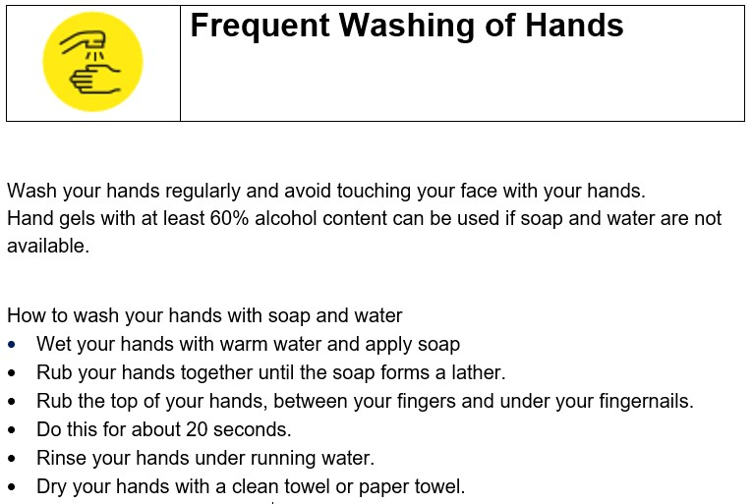
Person Responsible: |  | Employer / Site Supervisor
Training Requirements |  | Induction briefing on policies and Safety Awareness.
If all measures are followed properly, this activity will reduce the risk rating from High to Medium / Low risk.

PREVENTION Coughing / Sneezing Etiquette

Hazards: | Covid-19 is airborne and contracted by breathing in viral droplets, from an aerosol ejected during coughing, sneezing or even breathing.
Type of Activity: | Normal work activities
Risk To: | Employees / Other site users / Public |  | Risk Rating | HIGH
Consequences | Ill-Health – Health complications, respiratory issues
Findings
Current and additional control measures
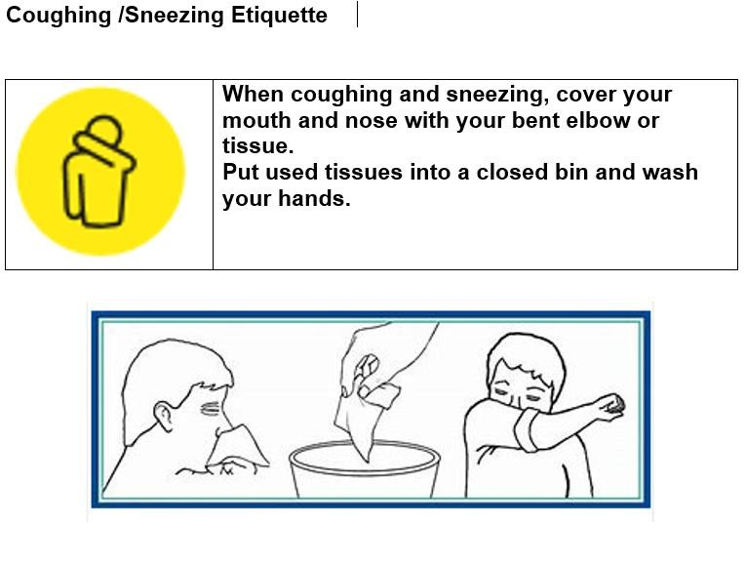
Person Responsible: |  | Employer / Site Supervisor
Training Requirements |  | Induction briefing on policies and Safety Awareness.
If all measures are followed properly, this activity will reduce the risk rating from High to Medium / Low risk.

PREVENTION Social Distancing

Hazards: | Covid-19 is airborne and contracted by breathing in viral droplets, from an aerosol ejected during coughing, sneezing or even breathing.
Type of Activity: | Normal work activities
Risk To: | Employees / Other site users / Public |  | Risk Rating | HIGH
Consequences | Ill-Health – Health complications, respiratory issues
Findings
Current and additional control measures
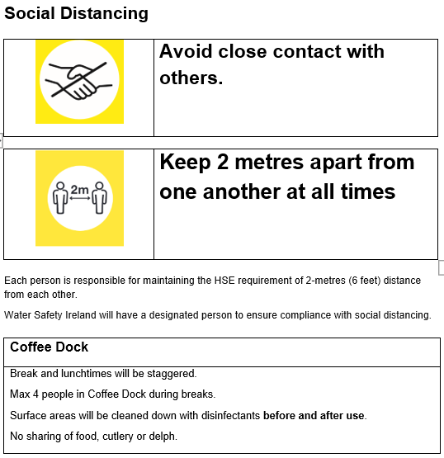
Person Responsible: |  | Employer / Site Supervisor
Training Requirements |  | Induction briefing on policies and Safety Awareness.
If all measures are followed properly, this activity will reduce the risk rating from High to Medium / Low risk.

PREVENTION Cleaning

Hazards: | Covid-19 is airborne and contracted by breathing in viral droplets, from an aerosol ejected during coughing, sneezing or even breathing.
Type of Activity: | Normal work activities
Risk To: | Employees / Other site users / Public |  | Risk Rating | HIGH
Consequences | Ill-Health – Health complications, respiratory issues
Findings
Current and additional control measures
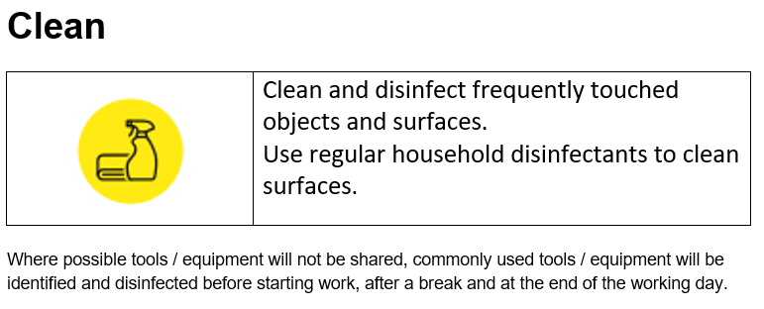
Person Responsible: |  | Employer / Site Supervisor
Training Requirements |  | Induction briefing on policies and Safety Awareness.
If all measures are followed properly, this activity will reduce the risk rating from High to Medium / Low risk.

PREVENTION Visitors / Deliveries

Hazards: | Covid-19 is airborne and contracted by breathing in viral droplets, from an aerosol ejected during coughing, sneezing or even breathing.
Type of Activity: | Normal work activities
Risk To: | Employees / Other site users / Public |  | Risk Rating | HIGH
Consequences | Ill-Health – Health complications, respiratory issues
Findings
Current and additional control measures
Customers
Visitors to the headquarters will be required to follow all Water Safety Ireland(WSI) safety requirements including Covid-19 precautions.

For deliveries
Delivery and pick-up arrival times will be pre-booked to ensure staff are available. Drivers will remain in cabs for the duration of loading and unloading.
Social distancing will be maintained Break areas are out of bounds to visitors Do NOT dispose of any waste on site.
Do NOT use any tools or equipment belonging to WSI.

Where any of these requirements cannot be met a Risk Assessment will be carried out to determine a safer method of performing the task.
Person Responsible: |  | Employer / Site Supervisor
Training Requirements |  | Induction briefing on policies and Safety Awareness.
If all measures are followed properly, this activity will reduce the risk rating from High to Medium / Low risk.

HAZARDS – OFFICE

Slips Trips Falls

Hazards: | Slippery surfaces / Poor housekeeping / Poor lighting / Uneven Ground
Type of Activity: | Access and Egress / General movement
Risk To: | Employees / Members / Public |  | Risk Rating | LOW
Consequences | Injuries / Cuts / Scrapes / Bruising /Broken Limbs
Findings | Housekeeping requires regular attention/decluttering in Offices and Storage areas.  Storage areas present access/egress, slip, trip and fall hazards  Alternative storage required for promotional materials and archive documentation
Current and additional control measures
- All areas will be kept free of debris, trash, spills at exits / passageways.
- Unused work equipment will be stored away.
- A housekeeping / cleaning programme is in place to manage the yard and site work floor, requires constant attention.
- Periodic checks are carried out to ensure that no obvious danger exists that might endanger the Employees.
- Protruding objects (that can block walkways) will be removed.
- Employees will report to management any unusual conditions they discover.
- All Employees will operate a "clean as you go" policy.
- Employees will report to supervisor poor lighting on site and wait for additional lighting to be secured before commencing with work activity.
- The yard/sheds etc. shall be kept clear of any rubbish / debris.
- Areas will be kept clear of obstructions.
Person Responsible: |  | Employer
Training Requirements |  | Regular Housekeeping checking and Safety Awareness

Temperature - Cold

Hazards:
Type of Activity: | General recreational / work activities
Risk To: | Employees / Members / Public |  | Risk Rating | MEDIUM
Consequences | Loss of tactile sensitivity / Hypothermia
Findings | Office temperature is maintained at a suitable level for the comfort of employees and visitors.
Current and additional control measures
- All heating devices will be maintained / serviced as per manufacturer’s instructions.
- Office temperature will be maintained at 17.5O C.

- Where the temperature of the workplace falls below a comfortable level the advice of site / company management will be sought.
Person Responsible: |  | Employer
Training Requirements |  | Health & Safety Induction on safety policies.
If all measures are followed properly, this activity will reduce the risk rating from Medium to Low risk.

Display Screen Equipment (DSE)

Hazards: | Posture / Glare
Type of Activity: | Working with Display Screen Equipment
Risk To: | Employees / Members / Public |  | Risk Rating | MEDIUM
Consequences | Upper Limb Pains / Eye Fatigue / Vision Damage / Posture Injuries / Muscle Strain / Damage
Findings | Minor ergonomic changes to a few workstations required.
Current and additional control measures
- All staff at risk will carry out a workplace assessment and problem areas identified will be addressed. This may include the purchase of additional or different equipment.
- Workstations to be designed to suit the DSE user and to comply with the current General Application Regulations.
- The work activities of DSE users designed to give periodic breaks away from the screen. Staff will be reminded to take periodic breaks.
- Work must be arranged to avoid awkward movements and encourage correct posture at all times.
- All DSE users to be trained in and given information on the safe use of the workstation to include: induction training, principles of ergonomics, furniture adjustment, screens, keyboards, lighting, fire escape plan and breaks.
- Additional workstation assessments may occur as needed where posture problems become apparent.
- Clean desk policy will be adhered to. This will assist in preventing any workplace injuries or awkward postures.
Person Responsible: |  | Employer
Training Requirements |  | Health & Safety Induction on safety policies.
If all measures are followed properly, this activity will reduce the risk rating from Medium to Low risk.

HAZARDS –

Hazards: | Boiling Liquids
Type of Activity: | Hot Liquids – Water / Oil - Hot Surfaces – Grills / Ovens
Risk To: | Employees / Members |  | Risk Rating | MEDIUM
Consequences | Burns / Scalds / Nausea / Headache
Findings | All kitchen duties supervised by a competent person. / Normal domestic appliances used.
Current and additional control measures
- Machines will be maintained as per manufacturer’s instructions.

- All safety features (thermostats etc.) will be maintained and functioning before an appliance is used.
- Appliances will be switched off when not in use.

- All staff will exercise caution while working close to hot surfaces.

- Except in special circumstances, access to the kitchen area will be limited to staff and controlled so as to prevent unauthorised access.
- Suitable gloves and aprons will be used for washing operations.

- Care will be exercised when opening lids on boilers and kettles to protect the face etc., and never reach across hot containers.
- When using water boilers, ensure that the cold water level is on full before you switch on the appliance and drip trays are in position.
Person Responsible: |  | Employer
Training Requirements |  | Health & Safety Induction on safety policies.
If all measures are followed properly, this activity will reduce the risk rating from Medium to Low risk.

Microwave Oven

Hazards: | Electric shock / Scalds / Microwave radiation
Type of Activity: | Cooking/Heating food in staff canteen / microwave ovens
Risk To: | Employees / Members / Public |  | Risk Rating | LOW
Consequences | Burns / Scalds / Electrocution.
Findings | All kitchen duties supervised by a competent person
Current and additional control measures
- Microwaves / ovens will be mounted within easy reach.
- Manufacturer’s instructions for operating microwave oven will be followed.
- Door seals will be kept free from food, grease, and dirt.
- Oven gloves will always be used to remove containers from the microwave.
- All maintenance / cleaning will be conducted with the machines disconnected from the power source.
- A tag will be placed on the control device during cleaning or repairs.
- Portable electrical equipment will be PAT tested and certified annually by a competent electrician.
DO NOT –
  - Use ovens with damaged doors, door seals or door interlock.
  - Use metal / decorated dishes in the microwave.
  - Bypass the door interlock and activate the oven with the door open.
  - Cook whole eggs, food in sealed containers, sealed plastic bags or food with non- porous casing (pressure build-up may break the casing and spill the contents).
  - Work near a microwave oven if wearing an unshielded heart pacemaker.
Person Responsible: |  | Employer
Training Requirements |  | Health & Safety Induction on safety policies.

HAZARDS – COMPANY VEHICLES

Company Vehicles

Hazards: | Poor visibility/driving conditions, Faulty Vehicles, Slippery Surfaces / Unsuitable Surfaces. Excess speed
Type of Activity: | Driving / reversing cars, vans, trailer
Risk To: | Employees / Public |  | Risk Rating | HIGH
Consequences | Accidents, Spinal Injuries, Head Injuries, Cuts / Scrapes, Broken Bones, Loss of Limb, Death
Findings | Driving for Work Policy in place.  All vehicles maintained as per Regulations / Road Traffic Act.
Current and additional control measures
- All Company vehicles will be fitted with breakdown kit containing:
  - First Aid Kit
  - Torch
  - Warning Triangle
  - Fire Extinguisher
  - High-vis Vest
- The organization’s and designated road speed limits will be complied with.
- Areas to be kept clear of anything that will obstruct a driver’s vision & substances that will contribute to slippery surfaces.
- A responsible person will guide all reversing operations with the driver.
- A competent person will carry out all maintenance operations and written records will be kept of work completed.
- Event and location traffic system will be complied with.
- Vehicles will be parked in the designated area only.
Person Responsible: |  | Employer
Training Requirements |  | Health & Safety Induction on safety policies.
If all measures are followed properly, this activity will reduce the risk rating from High to Medium / Low risk.

Company Vehicles - Trailers

Hazards: | Vehicle movement, excess speed, unbalanced loads
Type of Activity: | Movement of Machinery / equipment / trailers
Risk To: | Employees / Public |  | Risk Rating | HIGH
Consequences | Crushing/collision - injuries
Findings
Current and additional control measures
- Only suitable trailers will be used.
- Trailers will only be towed by suitable vehicles capable of moving the equipment safely.
- Trailers will be secured to the towing vehicle and a suitable emergency alternative in the event of a breakaway.
- Maintain good all-round visibility at all access points onto public / internal roadways.
- Warning signs will be placed on the road / pathways when machinery activity is in progress.
- All machinery will be maintained as per the manufacturer’s instructions and to comply with current relevant Legislation.
Person Responsible: |  | Employer
Training Requirements |  | Health & Safety Induction on safety policies.
If all measures are followed properly, this activity will reduce the risk rating from High to Medium / Low risk.

Refueling Machines / Vehicles

Hazards: | Fire / explosion, flammable fumes/vapours
Type of Activity: | Refueling machines, equipment, etc.
Risk To: | Employees / Public |  | Risk Rating | HIGH
Consequences | Burns, injuries, death
Findings
Current and additional control measures
- Fuels will be stored away from flammable materials / openings / sewers / excavations.
- No sources of heat to be present during refueling.
- Suitable fire extinguishers will be available in each machine.
- Smoking is prohibited in refueling area.
- Suitable / approved containers only will be used for storing / transporting fuels.
- All machinery / mobile phones must be switched off before any refueling/maintenance is attempted.
- Refueling will be carried out in the open / well-ventilated area.
Person Responsible: |  | Employer / Site Supervisor
Training Requirements |  | Health & Safety Induction on safety policies.
If all measures are followed properly, this activity will reduce the risk rating from High to Medium / Low risk.

Recharging / Jump Starting - Batteries

Hazards: | Electrocution, Battery Acid
Type of Activity: | Battery-- Recharge Disconnect /Reconnect, Jump starting
Risk To: | Employees / Members / Public |  | Risk Rating | LOW
Consequences | Explosion, Fire, Toxic fumes, Acid Burns, Electrical burns
Findings
Current and additional control measures
- Manufactures instructions should be strictly adhered to.

- Recharging will take place in a well-ventilated area with suitable fire extinguishers available.
- Switch off the battery charger before connecting and disconnecting the clips.

- Suitable PPE (goggles /gloves /overalls) will be worn.

- No metallic items to be worn on hands/wrists/neck.

- Ignition switches will be turned off during all dis/reconnecting operations.

- Always disconnect the earth first and reconnect it last using insulated tools.

- Do not rest tools or metallic objects on the top of the battery. Access to battery recharging area to be restricted.
- No smoking or naked lights to be permitted in charging area.
Person Responsible: |  | Employer
Training Requirements |  | Health & Safety Induction on safety policies.

HAZARDS – WATER SAFETY EQUIPMENT

CPR Mannequins

Hazards: | Transmission of Infectious Disease
Type of Activity: | Using CPR Mannequins
Risk To: | Employees / WSI Members / Public |  | Risk Rating | LOW
Consequences | Infectious Disease
Findings | Mannequins must be cleaned after each student with an appropriate disinfectant
Current and additional control measures
All mannequins will:
- Be maintained as per the manufacturers / supplier’s instruction.
- Be stored so as not to hinder access to emergency equipment.
- Be thoroughly disinfected between each use.

Person Responsible: |  | Employer, WSI Instructor
Training Requirements |  | Briefing on the relevant Water Safety Ireland policies

Rescue Boat – I.R.B.

Hazards: | Unqualified equipment operators, General water activities, Leaking / Faulty boats, Faulty Swivels, Damaged oars / sculls, excess speed
Type of Activity: | Training and competing with rescue equipment, Patrolling Competition Events
Risk To: | Employees / WSI Members / Public |  | Risk Rating | HIGH
Consequences | Injuries, Hypothermia, Drowning
Findings | All rescue boats operators have passed the ISA Level 2 Powerboat Handling Course or equivalent
Current and additional control measures
- All WSI boats / equipment will be operated by authorised and competent persons.
- All rescue boats used will be suitable and safe for the intended task:
  - Stable, quick and maneuverable.
  - Sufficient capacity for the transporting of injured members to safety.
- All rescue boats will be maintained in a safe condition, will be checked regularly and the results recorded.
- All outboards used will be fitted with a suitable “kill cord” which will be worn at all times by the operator while the boat is in motion.
- All operators will be suitably qualified and have the necessary experience of the rescue boats
/ engine / river / lake.
- All rescue boats operators will be qualified in first aid and cold-water immersion treatment.
- Regular training exercises will be carried out of all skills especially water rescue.
- All rescue boats will be equipped with all necessary equipment outlined in national rescue boat standards.
- All personnel in the launch will wear approved Lifejackets / Personal Floatation Devices (PFD). These must be the right size and a comfortable fit.
  - They will be worn over normal working clothes.
Person Responsible: |  | Employer, WSI Instructor
Training Requirements |  | Briefing on the relevant Water Safety Ireland policies
If all measures are followed properly, this activity will reduce the risk rating from High to Medium / Low risk.

Water Rescue Equipment – Ski’s and Boards

Hazards: | Unsuitable / Damaged Equipment, novice/untrained users
Type of Activity: | Training and competing with Rescue equipment
Risk To: | Lifeguards / Equipment Users |  | Risk Rating | LOW
Consequences | Injuries, Hypothermia, Drowning
Findings
Current and additional control measures
- Only suitable, approved equipment will be used by members.
- All equipment will be checked before use and defective equipment will be taken out of circulation until repaired / replaced.
Person Responsible: |  | Employer, WSI Instructor
Training Requirements |  | Briefing on the relevant Water Safety Ireland policies.

Quad Bikes

Hazards: | Lack of formal training or experience, Excessive speed, poor quad maintenance, particularly tires and steering, Poor physical mobility, carrying a passenger or an unbalanced load, Tipping on a bank, ditch, rut or bump, A steep slope combined with other factors e.g. ground or load conditions, Towing excessive loads with un-braked equipment.
Type of Activity: | Operating Organisation’s Vehicles
Risk To: | Employees / Public |  | Risk Rating | HIGH
Consequences | High velocity injuries, fatality
Findings | Driving for Work Policy in place.
Current and additional control measures
- Before using a Quad bike, driver will:
  - Undertake formal training.
  - Wear a helmet, high vis clothing, personal protective equipment and appropriate footwear - preferably boots.
  - Know the terrain they are travelling across.
  - Keep the quad maintained and in good condition.
  - Don’t overload racks - tools and equipment will be secured so as not to present a hazard to the driver.
  - Check tire pressure.
- Passengers will not be carried.

- It is illegal to drive Quad bikes on the road or pavement.

- The manufacturer’s weight restrictions shall be followed. In general, the max recommended weight for anyone driving a quad bike is between 18-20 stone (114-127Kgs).
- Drive at an appropriate speed for the conditions and environment.

- Quad bikes may be unsuitable for older operators with poor physical mobility and slower response times.
Person Responsible: |  | Supervisor
Training Requirements |  | Formal training on the driving of Quad Bikes.
If all measures are followed properly, this activity will reduce the risk rating from High to Medium / Low risk.

HAZARDS – WATER SAFETY COURSES

Beach + Pool Lifeguard Courses

Hazards: | Inadequate Training, Lack of experience, Inadequate knowledge of Emergency Equipment, Cold Water
Type of Activity: | Lifeguard training courses.
Risk To: | WSI Instructors / WSI Members |  | Risk Rating | MEDIUM
Consequences | Injuries, Hypothermia, Drowning
Findings | Only instructors approved to carry out these courses may do so  All courses must have prior approval from the local WSAC and WSI before the course may be commenced.
Current and additional control measures
- Instructors will conduct a pool safety rule briefing before commencing the course.
- Instructors will introduce pools emergency equipment, including ring buoys, reach pole, first aid kits and A.E.D. (if available), to all in attendance prior to commencing course.
- All courses will be conducted according the WSI procedures using the relevant manuals.
- WSI Pool Safety Guidelines must be followed during all pool related courses.
- Instructor to pupil ratios as advised by WSI will not be exceeded.
- The pupil’s susceptibility to hypothermia will be assessed. The duration of any water- based training will consider the results of the assessment.
- Suitable wet suits will be worn where permitted.
Person Responsible: |  | WSAC & WSI Instructor
Training Requirements |  | Briefing on the relevant Water Safety Ireland policies
If all measures are followed properly, this activity will reduce the risk rating from Medium to Low risk.

Water Quality - Water Borne Diseases

Hazards: | Water based training Activities - poor quality water. Animal urine – rats Weil’s Disease, Blue-Green Algae – Cyanobacteria, Harmful Algal Bloom, Sewage effluent discharges
Type of Activity: | Water Safety Instruction - Lakes / Rivers /Sea
Risk To: | Employees / WSI Members |  | Risk Rating | LOW
Consequences | Infectious Disease
Findings
Current and additional control measures
- Where possible, the water quality of a training facility or event venue, will be monitored / checked before any WSI activity takes place. If a doubt exists, an alternative venue or a postponement of the activity will be decided upon.
- All personnel operating on water (where the quality is doubtful) or handling WSI equipment will ensure that:
  - Cuts and abrasions (including blisters) are covered with waterproof dressings.
  - Appropriate footwear is worn to avoid cuts and protect feet when paddling in the water or launching boats.
  - They shower after contact with the water.
- They adopt good personal hygiene habits i.e. wash hands thoroughly before eating and drinking.
- Where possible immersion or contact with water affected by algae scum will be avoided. After any contact all equipment will be hosed down to avoid contact with any residual scum.
- Members will be instructed that all clothing should be washed and thoroughly dried on returning home.
- Members who have any concern about any possible health risk or suffering any adverse symptoms should be advised to attend the local doctor.
- Where the quality of the water is uncertain club members will be instructed:
  - Not to eat or drink before showering/washing.
  - And if ‘foul’ water has been swallowed medical advice will be sought.
Person Responsible: |  | Employer, WSI Instructor
Training Requirements |  | Briefing on the relevant Water Safety Ireland policies

Water Safety Weeks

Hazards: | Inadequate Training, Lack of experience / supervision, Inadequate knowledge of Emergency Equipment, Lack of knowledge of Open Water location, Poor Water Quality, Poor Accommodation
Type of Activity: | Training Activities
Risk To: | Employees / WSI Members / Public |  | Risk Rating | MEDIUM
Consequences | Injury, Drowning, Sickness, Ill health, Fire
Findings | All courses must have prior approval from the local WSAC before commencing the course
Current and additional control measures
- Only instructors approved by the WSAC will conduct water safety activities.
- A risk assessment must be carried out on all water and land-based locations to be used for the activity, prior to a course being granted approval.
- Clear guidance will be issued to the parents / guardians by the instructor/s on the times of instruction and the periods of supervision by the WSI person. The times for reporting and collection must be agreed and understood by all so no pupils is put at risk.
- An emergency action plan / procedure will be developed for the location.
- All class members / assistants etc will be briefed on how to handle any variations to normal procedures such as dealing with current / winds / climatic conditions etc.
- A first aid kit and a means of communication capable of alerting the emergency services will also be available locally.
- A suitable map / plan of the river / lake will be prominently displayed showing local hazards / obstacles
/ currents / navigation rules. All members will be briefed on the plan and all newcomers prior to going to the water.
- Instructors will conduct all activities as per the best practice advised by the WSI and its publications.
- Instructor to pupil ratios as advised by WSI will not be exceeded.
- The pupil’s susceptibility to hypothermia will be assessed. The duration of any water-based training will consider the results of the assessment.
Person Responsible: |  | Employer, WSI Instructor
Training Requirements |  | Briefing on the relevant Water Safety Ireland policies
If all measures are followed properly, this activity will reduce the risk rating from Medium to Low risk.

HAZARDS – WATER SAFETY COMPETITIONS

Adverse Weather Conditions

Hazards: | Hazardous water conditions, high winds, floods, fast running water.
Type of Activity: | Open Water Competition
Risk To: | Competitors, Stewards |  | Risk Rating | MEDIUM
Consequences | Drowning
Findings | Safety Officer is appointed for each Championship or Trial and safety officer determines if it’s safe for the event to proceed / continue
Current and additional control measures
- The expected prevailing weather conditions will be monitored by the event safety officer and if a doubt exists as to safety, the guidance of the WSI will be sought before the event takes place and anyone is put at risk.
- An alternative date / location will be considered in adverse weather conditions.
Person Responsible: |  | Employer, WSI Instructor
Training Requirements |  | Briefing on the relevant Water Safety Ireland policies
If all measures are followed properly, this activity will reduce the risk rating from Medium to Low risk.

Crowd Control

Hazards: | Dangerous Viewing Points, Egress - Restricted exit space
Type of Activity: | General assemblies
Risk To: | Competitors / Public |  | Risk Rating | LOW
Consequences | Infectious Disease
Findings | ILS Competition Rule book guideline on crowd control followed
Current and additional control measures
- Competent persons will supervise all competitions
- All egress from assembly areas will be organised to take account of the exit space available.
  - The maximum capacity of the intended exit will not be exceeded.
  - All egress will be controlled by the supervisory staff.
- Competition staff must secure any spectator area where members of the public may injure themselves.
Person Responsible: |  | Competition Controller, Safety Officer
Training Requirements |  | Briefing on the relevant Water Safety Ireland policies

Swimmers - Open Water Activities

Hazards: | Cold Water, Currents, Rip tides
Type of Activity: | Competitions
Risk To: | Stewards, Competitors, Rescue teams |  | Risk Rating | HIGH
Consequences | Injuries, drowning
Findings | Rescue skill handbook and instructor’s handbook guidelines will be adhered to at all times.
Current and additional control measures
- Only competitors physically suitable for the competition will be permitted to enter the water.
- All competitions will be under the control of an event organiser, who will be competent.
- All persons entering / exiting the water will be controlled and closely monitored by competition officials.
- Where required, the required number of rescue boats / canoes / skis will be in the water and located to cater for emergencies.
- The required emergency equipment, to include a first aid kit will be on hand.
- Information on possible support bodies e.g. local medical facilities, Met Eireann, Marine Rescue etc. will be kept readily available.
- An appropriate number of survival blankets must also be available.

- Suitable Lifejackets / Personal Floatation Devices (PFD) will be worn. These must be the right size and a comfortable fit.
o Lifejackets will be worn over normal working clothes.
Person Responsible: |  | Employer, WSI Instructor
Training Requirements |  | Briefing on the relevant Water Safety Ireland policies
If all measures are followed properly, this activity will reduce the risk rating from High to Medium / Low risk.

HAZARDS – WATER SAFETY MEMBERS

Bullying / Harassment / Challenging Behaviour

Hazards: | Bullying, Harassment, Challenging Behaviour
Type of Activity: | Attending / Participating in WSI activities / events
Risk To: | Employees / Members / Public |  | Risk Rating | LOW
Consequences | Fear / Anxiety / Depression
Findings | - WSI Guidelines on Child Protection are followed by all instructors  - Designated Liaison Person appointed for all water safety groups  - All water safety instructors trained in child protection guidelines
Current and additional control measures
- Instructors will report their suspicions to the Designated Liaison Person.
- Instructors will forward any reports received of inappropriate behaviour to the Designated Liaison Person.
- Approved WSI instructors will supervise all activities.
Person Responsible: |  | All personnel
Training Requirements |  | Health & Safety Induction on safety policies.

Drugs and Alcohol

Hazards: | Intoxicants -> Loss of control
Type of Activity: | Operating Equipment, Attending / Participating in WSI activities / events
Risk To: | Employees / Members / Public |  | Risk Rating | LOW
Consequences | Injury / Loss of limb / Loss of life
Findings | - Employees monitored by Management  - Members are monitored by local area committee  - WSI’s Code of Ethics guidelines outline organisation’s policy on Drugs and alcohol
Current and additional control measures
- All water safety instructors will be briefed on the signs and symptoms of drug abuse.
- All staff will report to WSI management any suspicions / finds of such abuse / use.
- The WSI management will use the appropriate investigative agency to examine such finds / suspicions.
Person Responsible: |  | Employer / All employees
Training Requirements |  | Health & Safety Induction on safety policies.

Medical Conditions - At Risk Members

Hazards: | Inadequate Knowledge, Lack of training, Improper handling
Type of Activity: | Sport Activities
Risk To: | WSI Members |  | Risk Rating | MEDIUM
Consequences | Accidents, Discomfort, Injury to student with physical disability / medical condition / injury to staff
Findings | Members or member’s guardians are requested to report any medical conditions to the WSI on enrolment, following an injury or illness.
Current and additional control measures
- Information on the student specific condition / needs will be collated and made known to designated staff.
- Training will be given on the particular needs of each person and their implications for safe handling.
- All necessary instructors will familiarise themselves with relevant information on each person’s needs.
- Training will cover appropriate moving and handling practice and all practices involved in the care of members.
- Policies and procedures will be followed regarding confidentiality, communication, interaction with staff and members.
Person Responsible: |  | Employer, WSI Instructor
Training Requirements |  | Briefing on the relevant Water Safety Ireland policies
If all measures are followed properly, this activity will reduce the risk rating from Medium to Low risk.

Special Needs Members

Hazards: | Lack of Mobility, Lack of Knowledge
Type of Activity: | Access & Egress, Classroom Activities, Sports Activities
Risk To: | Employees / WSI Members / Public |  | Risk Rating | LOW
Consequences | Injury to self or others
Findings | The organisation is wheelchair accessible
Current and additional control measures
- The specific needs of the individual members will be assessed, and the appropriate measures will then be taken to safeguard their welfare.
- All emergency procedures / measures will cater for members with special needs.
- Suitable Lifejackets / Personal Floatation Devices (PFD) will be used. These must be the right size and a comfortable fit.
- PDF’s will be worn over normal working clothes.
Person Responsible: |  | Employer, WSI Instructor
Training Requirements |  | Briefing on the relevant Water Safety Ireland policies

HAZARDS - MAINTENANCE

Chemicals

Hazards: | Cleansing Agents / Solvents
Type of Activity: | Using Chemicals / Storing chemicals
Risk To: | Employees / Members / Public |  | Risk Rating | LOW
Consequences | Contamination / Ill-health / Dermatitis / Burns
Findings | Domestic cleaning materials stored in press and storeroom
Current and additional control measures
- Access to chemicals will be on a need only basis and only by persons who have received the required safety training / instruction.
- All employees using chemicals will read the labels and follows instructions for use.
- Material Safety Data Sheets shall be available for all chemicals on site, and will be an appendix of this safety statement.
- Chlorine bleaches will not be mixed with other cleaning agents.
- Good personal hygiene habits will be observed, and contaminated clothing should be removed when work is completed.
- Smoking in / around the vicinity of chemicals / paints / solvents is strictly forbidden.
Person Responsible: |  | Employer
Training Requirements |  | Health & Safety Induction on safety policies.

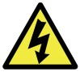
Electricity

Hazards: | Electricity
Type of Activity: | Using / servicing electrical equipment / appliances
Risk To: | Employees / Members / Public |  | Risk Rating | MEDIUM
Consequences | Electrocution / Burns / Cardiac Arrest / Broken Bones / Death
Findings | Portable electrical equipment must be PAT tested and tagged annually by a competent electrician. Normal electrical sockets and appliances.
Current and additional control measures
- To prevent overloading of sockets the golden electrical rule is ‘one appliance per socket,
- Only authorised personnel, competent to prevent danger, will undertake repairs, servicing, removal, installation and operating all electrical appliances.
- All electrical work is carried out by a competent person and completed to the Electrical regulations (ETU) Standards.
- The provisions of SI 44 Part V111 are complied with.
- All sockets’ outlets feeding portable/ domestic appliances / water service appliances are fitted with RCD protection.
- Every switch/ circuit breaker / or control device is clearly marked to indicate “On” and “OFF”.
- Regular checks to be carried out by a competent electrical contractor in line with the current edition of the ETCI Rules.
- Written records will be maintained of all servicing /installation /removal of electrical equipment.
- Check that suspect or faulty equipment is taken out of use, labelled ‘DO NOT USE’ and kept secure until examined by a competent person where possible, tools and power socket-outlets are switched off before plugging in or unplugging.
- Equipment is switched off and/or unplugged before cleaning or making adjustments.
- All electrical panels and distribution boards will be suitably identified, properly secured, and signed where necessary to prevent danger.
- Periodic audits will be carried out and recorded, by a competent person to ensure that all electrical fixtures / circuits / machinery are safe.
Person Responsible: |  | Employer
Training Requirements |  | Health & Safety Induction on safety policies.
If all measures are followed properly, this activity will reduce the risk rating from Medium to Low risk.

Hand Tools

Hazards: | Flying fragments / Split Handles / Mushrooming / split heads Pointed / sharp edges
Type of Activity: | Use of Hand Tools
Risk To: | Employees / Members / Public |  | Risk Rating | LOW
Consequences | Shock / Fractures / Lacerations / Contusions / Eye injuries
Findings | Portable Electronic Equipment is PAT tested and certified annually.
Current and additional control measures
- All tools must be suitable for the task and must be checked before use.
- Damaged, defective, or worn/suspect tools will be removed from service until repaired
or replaced.
- Competent persons will carry out all repairs / adjustments of the tools.
- Guards / safety devices must not be tampered with and if the tool is suspect, it will be taken out of service until checked by a competent person.
- All split / damaged handles will be replaced immediately.
- Hammers / chisels / punches used will be capable to withstand blows without mushrooming.
- Where required heads will be dressed suitably.
- All sharp / pointed tools, when not in use will have the edge / blade suitable protected.
- Appropriate personal protective equipment will be worn
Person Responsible: |  | Employer
Training Requirements |  | Health & Safety Induction on safety policies.

Ladders

Hazards: | Unsuitable or damaged Ladders / Steps, Hop-Ups
Type of Activity: | Working at Height
Risk To: | Employees / Members / Public |  | Risk Rating | HIGH
Consequences | Accidents / Electrocution / Spinal Injuries / Head Injuries / Cuts / Scrapes / Broken Bones / Loss of Limb / Death
Findings | Only ladders that conform to EN131 will be used. Stairs must have suitable handrails. Steps / Hop-Ups must be stable and capable of supporting person.
Current and additional control measures
- Do not work at height unless it is essential.
- Before using ladders, check that they are undamaged in any way and are suitable for the task, secure and cannot slip. Also ensure that it will support the weight of the worker.
- Always ensure that the ladder is angled to minimise the risk of slipping. Ensure non- slip feet or spurs are fitted to the ladder and are serviceable.
- As a general "rule of thumb" the ladders needs to be out one for every four up.
- Where the ladder is over 3 meters high, it will be secured at the top. If the ladder cannot be fixed, a second person foots the ladder while it is being used, the ladder must extend a sufficient height (about 1 meter) above any landing place, where people will get on or off.
- Do not stand on the ladders top three rungs.
- Under no circumstances will any employee put himself at risk by over-reaching or carrying loads up/down ladders. Employees will use the buddy system.
- Climb and descend the ladder facing the ladder and using both hands.
- Any ladders showing any signs of defects will be reported and removed from site.
- Do not drop, toss, or throw a ladder. Care will be taken to ensure that ladders will not come in contact with power cables.
- Stepladders should be securely spread open. Never use a folding stepladder in an unfolded position.
- Ladder Inspections will occur at least annually, in tandem with a full health and safety audit and fire drill.
Person Responsible: |  | Employer
Training Requirements |  | Health & Safety Induction on safety policies.
If all measures are followed properly, this activity will reduce the risk rating from High to Medium / Low risk.

Power Tools

Hazards: | Electricity / damaged / Faulty Equipment / Flying Fragments
Type of Activity: | Normal Work Activities with Power / Electrical Tools
Risk To: | Employees / Members / Public |  | Risk Rating | MEDIUM
Consequences | Shock / Fractures / Lacerations / Contusions / Eye injuries
Findings | Portable Electronic Equipment is PAT tested and certified annually.
Current and additional control measures
- All tools maintained as per the Manufacturer's instructions and a record must be kept of the servicing.
- All tools must be checked before use.
- All power tools must comply with current regulations, both for noise and vibration.
- In harsh environments the possibility of using air, hydraulic or hand powered tools must be considered.
- Power / electrical tools will only be operated by qualified / competent personnel (over eighteen years of age) who have been trained.
- Extensions leads to be avoided where possible and only correctly rated leads (fully uncoiled) may be used, elevated above head level, where absolutely necessary.
- Where the mains are used as a power source, a residual current device must be fitted (rated at 30m Amps, with no time delay).
- Damaged, defective, or worn / suspect tools will be removed from service until repaired.
- Competent persons will carry out all repairs / adjustments with the appliance / tool disconnected from the power source.
- Guards / safety devices must not be tampered with and if the appliance is suspect it will be taken out of service until checked by a competent person.
- Appropriate personal protective equipment will be worn.
Person Responsible: |  | Employer
Training Requirements |  | Health & Safety Induction on safety policies.
If all measures are followed properly, this activity will reduce the risk rating from Medium to Low risk.

Sub-Contractors

Hazards: | Untrained Sub-contractor Staff
Type of Activity: | Work being carried out by sub-contractors for WSI
Risk To: | Employees / Members / Public |  | Risk Rating | MEDIUM
Consequences | Injuries
Findings | Accidents / Injuries
Current and additional control measures
- Sub-contractor Safety documentation to be filed before starting the job.
- All sub-Contractors must comply with current Regulations.
- Sub-Contractors and Self-Employed Persons must provide their safety statement and methods statements when requested to do so.
- Sub-Contractors and Self-Employed Persons must provide evidence when requested, showing that appropriate Public Liability insurance in effect.
- Sub-Contractors and Self-Employed Persons must conform generally with the duties and responsibilities as for Staff.
- Sub-Contractors and Self-Employed Persons will ensure that their Staff and others under their care are provided with personal protective equipment as appropriate.
- Sub-Contractors and Self-Employed Persons must only use competent and suitable persons on the job.
- Any person found not complying with the above or any other safety directive will not be permitted to continue working.
Person Responsible: |  | All contractors must comply with the provisions of the SHAWW Act 2005.
Training Requirements |  | Health & Safety Induction on safety policies.
If all measures are followed properly, this activity will reduce the risk rating from Medium to Low risk.

DECLARATIONS

Employees Declaration
I hereby declare that I have read the Organisation’s Safety Statement, understand its contents, and I will comply with its requirements.

NAME (block capitals) | Signature / Date | Comments / Observations

Employees Declaration
I hereby declare that I have read the Organisation’s Safety Statement, understand its contents, and I will comply with its requirements.

NAME (block capitals) | Signature / Date | Comments / Observations

Certificate of Compliance: Sub-Contractors
I confirm that I have read and studied the relevant sections of the Safety Statement as it applies to us and our company employees will comply with its requirements.
All company Employees are issued with the necessary Personal Protective Equipment as required and are instructed to wear / use it at all times on site.
All company Employees have been instructed to report all accidents / problems / and hazards identified to the Safety Coordinator immediately.
All company Employees accepts all the requirements for working in a safe manner as outlined in the Safety Statement and will fully co-operate in all areas to support and improve the safety on site.
List of Sub-Contractors

Date | Nature of Work / Service | Company Name | Signature | Comment

