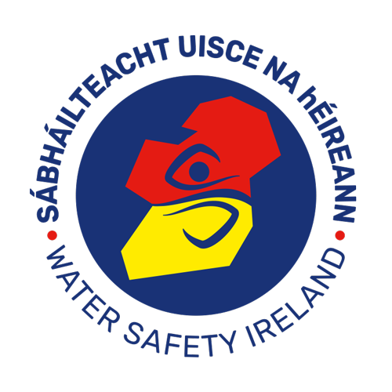

Guidelines for the Water Safety Ireland

Des Kenny Award

1 Introduction
The aim of these Guidelines is to define the purpose of, and the criteria for granting, the “Des Kenny Award”. They stipulate the process by which nominations for the Award will be received, prepared, examined and decided; the form of the Award; and the manner in which it will be awarded.

2 Purpose and Criteria
The purpose of the Award is to provide a unique, national recognition for those Water Safety Ireland (WSI) members who perform Basic Life Support (BLS) outside of their occupation or official voluntary activities.
The Award may be conferred on individuals or groups of individuals.
The Award may also be granted posthumously.

3 Eligibility
Any WSI member of any category undertaking or assisting in performing BLS in Ireland or any WSi member undertaking or assisting in performing BLS in a foreign country is eligible for nomination for the award.
In all cases the intervention must be outside of their occupation or official voluntary activities.

4 Nominations
Members of WSI should make nominations for the Award. Nominations should be submitted on the Des Kenny Award Nomination Form. Such nominations should be addressed to the Chief Executive, Water Safety Ireland HQ.

5 Process
Nominations received at WSi HQ will be sent to the appropriate WSAC for
Investigation (see Guidance Notes below for Water Safety Area Committees).
The Area Committee has primary responsibility for the preparation of recommendations for the possible granting of the Award.
6 When investigating the service performed, particular care must be taken not to give any indication of the recommendation that may be made or the possible outcome of the investigation.
7 Recommendations from the Area Committee should provide a full description of the circumstances and events giving rise to the nomination. See Guidance Notes below.
8 Speed in assessing the intervention meriting the Award is essential. This must be a top priority to undertake these investigations when requested to do so. As a general rule the Area Committee will complete their preparation of recommendations in four weeks and return them to the Chief Executive, WSI HQ.
9 The Chief Executive has the final responsibility for endorsing and submitting the Area Committee’s recommendations to the WSI Rescue Commission.
10 The Rescue Commission at its scheduled meetings will examine and decide upon all recommendations submitted to it by the Chief Executive.
11 The decision of the Rescue Commission will be final and there will be no leave to appeal that decision.
12 75% attendance of the Rescue Commission members will be required for decisions.

13 Form of the Award
The Award will take the form of an engraved Medallion together with a certificate, citing the rescue service performed from WSI.

16 Presentation of the Award

The Award will be presented at the WSI Awards Ceremony, which will take place in November each year.
If an award is made the nominee may be subjected to publicity

Guidance Notes for Water Safety Area Committees

A recommendation for a Des Kenny Award will necessitate the following actions to be carried out by members of the WSAC

- A visit to the location
- The interviewing of the personnel, casualties(y), witnesses and any others who can provide proof of the service provided and/or of participants,
- Confirmation of the details listed in each section of the Nomination Form
- Completion of the Award Nomination Form

- A comprehensive written report supported by all other available documentation to be completed in Nomination Form or/and by accompanying letter.

