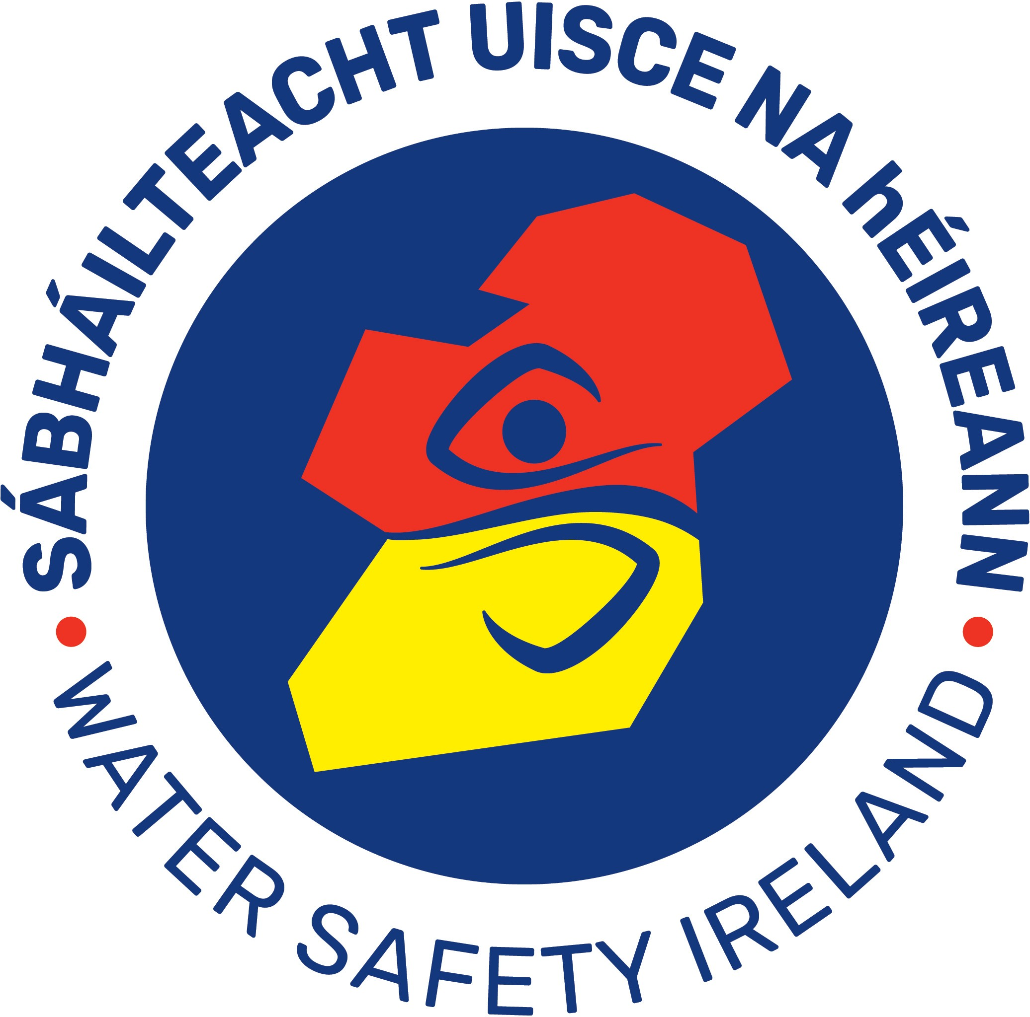
Course Registration Form
WSI IRB Crew / Driver Award

This form should be completed and forwarded to IWS National Office at least 14 days in advance of the start date of an IRB course. Course Providers must forward details to relevant WSACs. (All providers/organisers must be WSI members).
Revalidation requires 6 CPD points in a 2 year period or have attended a re-validation course in a 2 year period. Certificates will not be issued until all invoices pertaining to courses are paid. Unfortunately we cannot accept returns.

(Please tick appropriate boxes)

National IRB Crew Award or National IRB Crew Revalidation Award
National IRB Driver Award or National IRB Driver Revalidation Award
N.B. Candidates must be at least 16 years old to complete these courses.
Organised by:
1. Water Safety Area Committee *(must be minuted by WSAC Secretary)

Proposed starting date: Proposed concluding date:
Course Organiser :
(Note: Invoice issued to Course Organiser)

Name of Course Tutor:
Tel #:
Tel #:

Name of Course Examiner/Senior Tutor Tel #:
Tel #:

Number of candidates (New): Number of IRB Manuals/Log Books required:
(Max. 6 per Tutor)

Number of Candidates (Revalidating)

Shipment Address:

Phone No. Fax No E-mail. PO No. (If applicable)
Course Organiser Signature: Course hours as per syllabus
Location Details Venue:

Course approved? Yes/No IRB Commission Notified of Course? Yes/No
HQ use only

Signature: Lt. Cdr. John F.M. Leech (CEO)

Date:
HQ use only
Is Course Provider Registered and Up to Date? Yes/No
Is Examiner / Senior Tutor a Registered Provider of the Course? Yes/No

