WATER SAFETY IRELAND
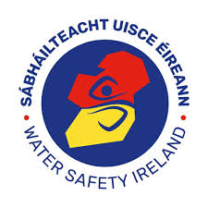
SÁBHÁILTEACHT UISCE na hÉIREANN

WATER SAFETY EXAMINATION RETURN
Head Office:
The Long Walk, Galway
Ireland
Tel: 353+91 56 44 00
Fax: 353+91 56 47 00
email: info@watersafety.ie
website: www.watersafety.ie

Course held at: Exam Venue Town County __ Date

 |  |  |  |  |  |  |  | SEAL
Name (Block Capitals) | I.D. | Address |  | Town | email | M/F | D.O.B. | 1 | 2 | 3 | 4 | 5
1.
2.
3.
4.
5.
6.
7.
8.
9.
10.
I agree to the management of my personal data in accordance with the General Data Protection Regulations (GDPR) 2018. |  |  |  |  |  |  | Total
Examiner:  BLOCK CAPITALS SIGNATURE  Instructor:  BLOCK CAPITALS SIGNATURE  Return completed form to your certificate secretary |  |  | Class Secretary:  Name: Address:  Phone: email:

