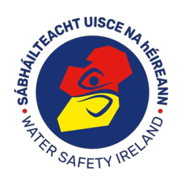

Water Safety Ireland
Continuing Professional Development for Swimming Teachers

All WSI Swimming Teachers are required to complete two hours of CPD every two years after they qualify. This applies to both Full and Assistant Swimming Teachers

A CPD Seminar will take place on:
Date Thursday 27th January 2022
Time 19.30-22.00
Via Zoom
Cost: €50

Topic
- Breast Stroke

All participants will receive a certificate of attendance for the seminar

Name: ______________________________________
Address: ____________________________________
____________________________________________
____________________________________________
____________________________________________
____________________________________________

Qualification: _____________________________ Date of Qualification: __________

All queries to: John Farrell, 0872831964/jftrainingservices@gmail.com

