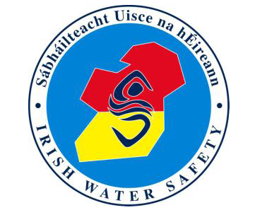 Date: ____________________
Amount Paid:

Autumn Classes: __________________Sig:

Spring Classes: ___________________Sig:

REGISTRATION FORM

Child’s Name: _____________________________________

Address: _________________________________________

_________________________________________

Date of Birth: ____/____/________

Email address: _______________________________

Telephone Number: ___________________________

Mobile Number: __________________________

Swim/ Water Safety Level Attained: __________________

Medical issues we need to be aware of:-

______________________________________________

My child wishes to take part in Irish Water Safety classes and is happy to obey the rules of the Pool and the organisation:

The above named child will become a young member of IWS.

I agree to the management of my personal data in accordance with the General Data Protection Regulations (GDPR) 2018

Parent/Guardian Signature: ________________________________

