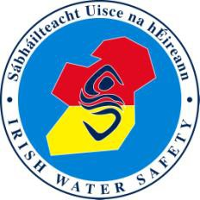
Swim Tutor Availability and Personal Information Consent Form
Name:

Address:

Contact Details:
Mobile Home Work E Mail Website:

Please indiciate your availability, by circling the appropriate heading(s), for the provision of Assistant and Full Swimming Teacher Courses.

Evenings only Weekends only Anytime
All year Part of year(Specify)
Please outline the extent to which you are willing to travel to deliver such courses.

Locally only (Specify area)

Provincially (Specify)

Anywhere (Specify limits, if any)

Please sign and return this form if you are willing to authorise Irish Water Safety to advertise your name and details as a provider on the IWS web site, and to permit staff to pass on your name and contact details in response to public enquiries.
You also agree to the management of your personal data in accordance with the General Data Protection Regulations (GDPR) 2018.

Signed (Tutor)

Signed (Witness)

Date

