Irish Water Safety Course Registration Form
Irish Water Safety
The Long Walk
Galway
Web: www.iws.ie
Email: info@iws.ie
Tel: 091 564400
Fax: 091 564700

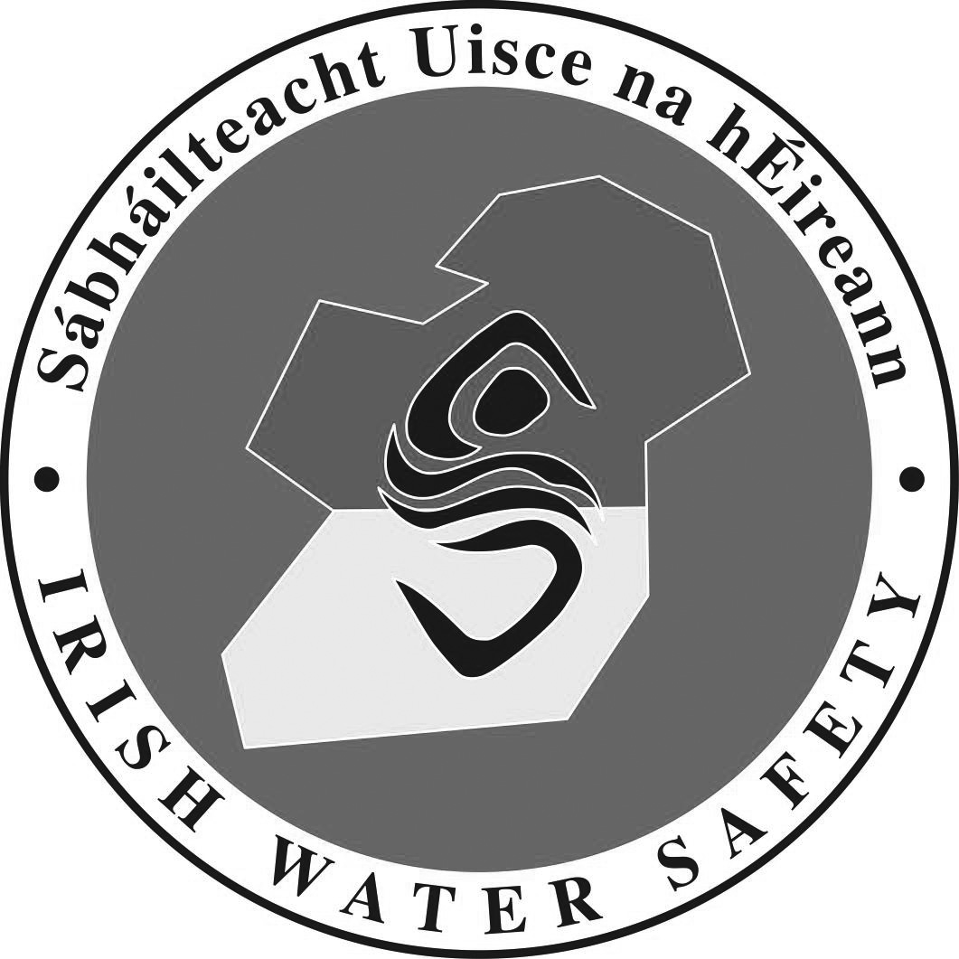

Swim Teacher Courses

This form should be completed and forwarded to IWS National Office at least 14 days in advance of the start date of a Swim Teacher course. Course Providers will forward details to relevant WSACs. All tutors must be IWS members.
I agree to the management of my personal data in accordance with the General Data Protection Regulations (GDPR) 2018.

Assistant Swim Teacher Course Full Swim Teacher Course
Organised by (tick appropriate box);

AWSC IWS Approved Tutor IWS Approved Organisation

Contact Details

Name: __________________________________________________________________

Address: __________________________________________________________________

Phone No:_______________ Fax No: _____________ E- Mail: ________________

Course Details

Proposed starting date: _____________ Proposed concluding date: _____________

Venue: ___________________________________________________________________

Number of Candidates: _______

Course Tutors: _____________________________ _ Tel No ________________

______________________________ Tel No ________________

Course Examiners: ___________________________ Tel No ________________

____________________________ Tel No _ _______________

Timetable Details

Theory Hours _____ Practical Hours ______ Total Hours ______

Swim Teacher Manuals Required ____ Assistant Swim Teacher Log Books Required ____

Full Swim Teacher Log Books Required ____

Office Use Only

Signature: __________________________________ Date Ratified: ________________

Lt. Cdr. John F.M.Leech, C E O

