Irish Water Safety Course Registration Form

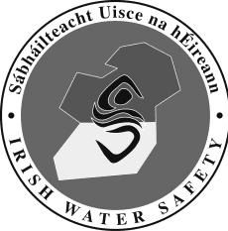
Swim Teacher Courses
Irish Water Safety The Long Walk Galway
Web: www.iws.ie Email: info@iws.ie Tel: 091 564400
Fax: 091 564700

This form should be completed and forwarded to IWS National Office at least 14 days in advance of the start date of a Swim Teacher course. Course Providers will forward details to relevant WSACs. All tutors must be IWS members.
I agree to the management of my personal data in accordance with the General Data Protection Regulations
(GDPR) 2018.

Assistant Swim Teacher Course Full Swim Teacher Course
Organised by (tick appropriate box);

AWSC IWS Approved Tutor IWS Approved Organisation

Contact Details

Name:

Address:

Phone No:
Fax No:
E- Mail:

Course Details

Proposed starting date: Proposed concluding date:

Venue:

Number of Candidates:  Course Tutors: _ | Tel No
 | Tel No
Course Examiners: | Tel No
 | Tel No | _

Timetable Details

Theory Hours
Practical Hours
Total Hours

Lt. Cdr. John F.M.Leech, C E O
Date Ratified:
Signature:

Swim Teacher Manuals Required Assistant Swim Teacher Log Books Required

Full Swim Teacher Log Books Required

Disclaimer: Unused manuals must be returned within 28 days to receive a refund. Otherwise the full cost will apply.

Office Use Only

