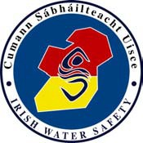
The Long Walk Galway Ireland
The Long Walk Galway Ireland
Tel: 091 – 564400
Fax: 091 – 564700
e-mail: info@iws.ie website: iws.ie
IRISH WATER SAFETY
CUMANN SÁBHÁILTEACHT UISCE
Tel: 091-564400
Fax: 091-564700
e-mail: info@iws.ie website: iws.ie
website: iws.ie
Lo-Call 1890 420202

Irish Water Safety The Long Walk, Galway

Area Committee

Date:

A chara,
Grant Requisition

A copy to be retained on Committee’s file.
My committee requires € grant to cover its actual or estimated expenditure (detailed below) over the coming weeks. I have been authorised by the Committee to make this request and to say that we consider the request to reflect our expenditure needs realistically. I certify that the committee’s bank balance today is € , while bills awaiting payment total € . All voluntary fundraising to date has been forwarded to Irish Water Safety.

On behalf of the Committee

Details of costs:

I agree to the management of my personal data in accordance with the General Data Protection Regulations (GDPR) 2018.

