Irish Water Safety
The Long Walk

ACCIDENT/ INCIDENT
REPORTING FORM

DETAILS OF INJURED PERSON
Name:
Galway
1890 420 202 (24 Hrs)
info@iws.ie www.iws.ie

Is the injured person: IWS Member Student Visitor Contractor
Address: Parent / Guardian (If Student)

DETAILS OF ACCIDENT
Date of Accident: Time of Accident:

Location:

Exact area/location where the Accident occurred?

Describe in detail what the injured person was doing at the time of the Accident and how the Accident
occurred?

Version 1 - Jan 2009 - © Irish Water Safety

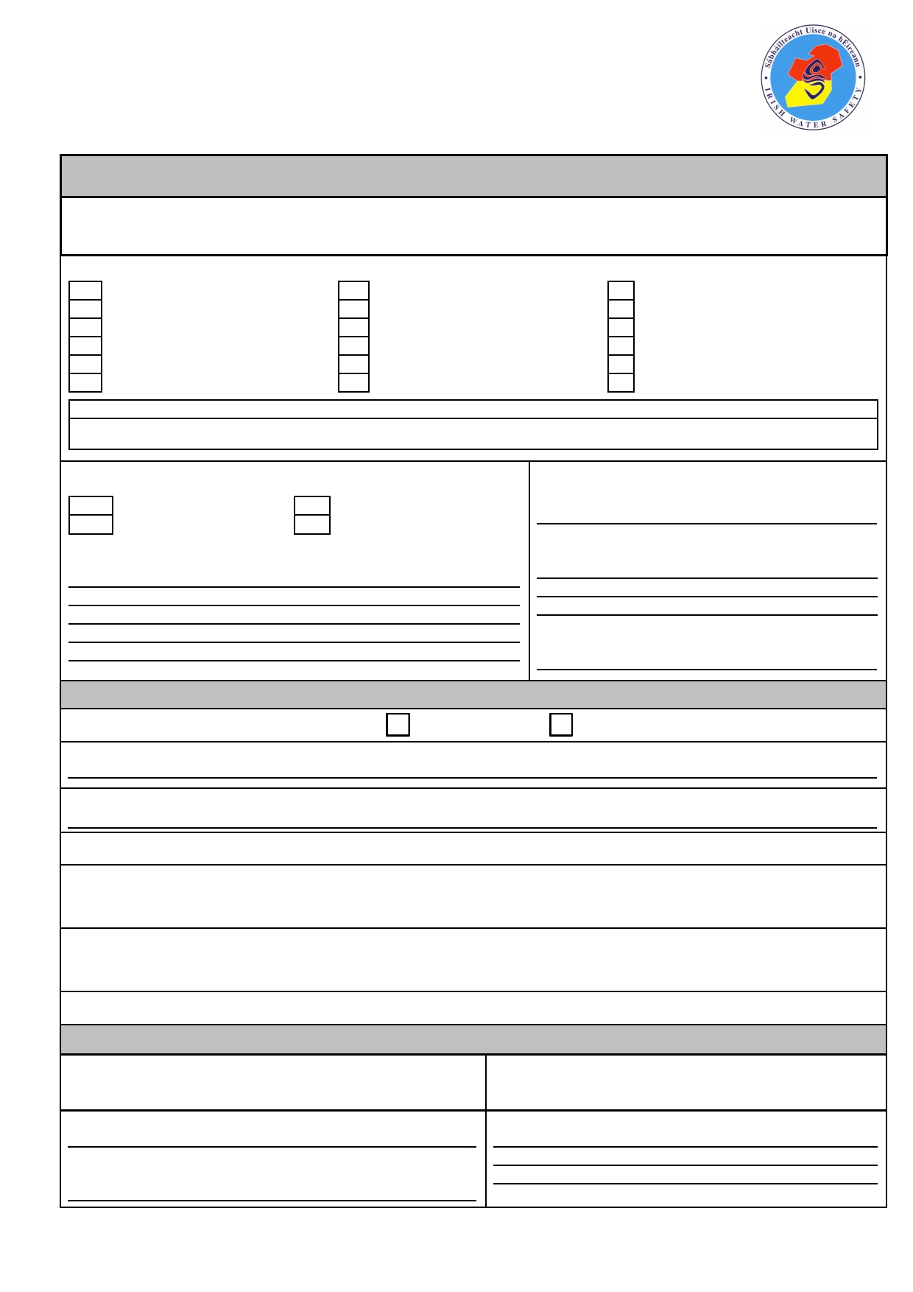
Irish Water Safety
The Long Walk

ACCIDENT/ INCIDENT
REPORTING FORM

ACCIDENT REPORT FORM
DETAILS OF INJURY
Describe the type of Injury:

Indicate part of the body most seriously injured:
Galway
1890 420 202 (24 Hrs)
info@iws.ie www.iws.ie

Head, except eyes
Back, spine
Shoulder
Hand Knee Toes
Other: (Describe)
Eyes
Chest
Upper arm, elbow
Fingers
Lower leg, ankle area
Extensive parts of the body
Neck
Abdomen
Lower arm, wrist
Hip joint, thigh
Foot
Multiple injuries

Was medical attention administered by: Was there any Witness to the Accident?
Name of Witness:
First Aider Doctor
Hospital None Required
Address:
Please specify i.e. Name & Medical Practice:

Phone Number:

To be filled in cases of Hospitalisation ONLY
Was injured person brought to hospital? Yes No
By what means of transport was the injured person brought to hospital?

Who brought the injured person to hospital ?

Name of Hospital:
Was the injured person admitted to hospital (please provide details of ward and length of stay):

What medical treatment was administered?

Is further medical treatment required?

Sign Off I agree to the management of my personal data in accordance with the General Data Protection Regulations (GDPR) 2018.

Signature of Accident Reporter: Signature of Injured Person:

Name of Accident Reporter: Address of Accident Reporter:

Date of Report:

Version 1 - Jan 2009 - © Irish Water Safety

